**Instructions:**

* All **expenses must be approved by the VP Finance** before any purchases and reimbursements can be made
* Collect receipts from all purchases and add them to this document
  + Please type down the **month and year** the purchase occurred along with the **receipts** provided by the purchaser
* **E-Transfers:** Add in the E-Transfer screenshot from the bank account or the bank statement, provide the receipts adding up to the reimbursement, and the reason for the transaction
* **\*Note that reimbursements can only be made by the VP Finance**

# 

# 

# 

# 

# 

# 

# 

# 

# 

# 

# 

# 

# 

# 

# 

# 

# 

# 

# 

# 

# 

# 

# 

# 

# 

# April 2024

## E-Transfer Line on Bank Account:



Original Receipts:

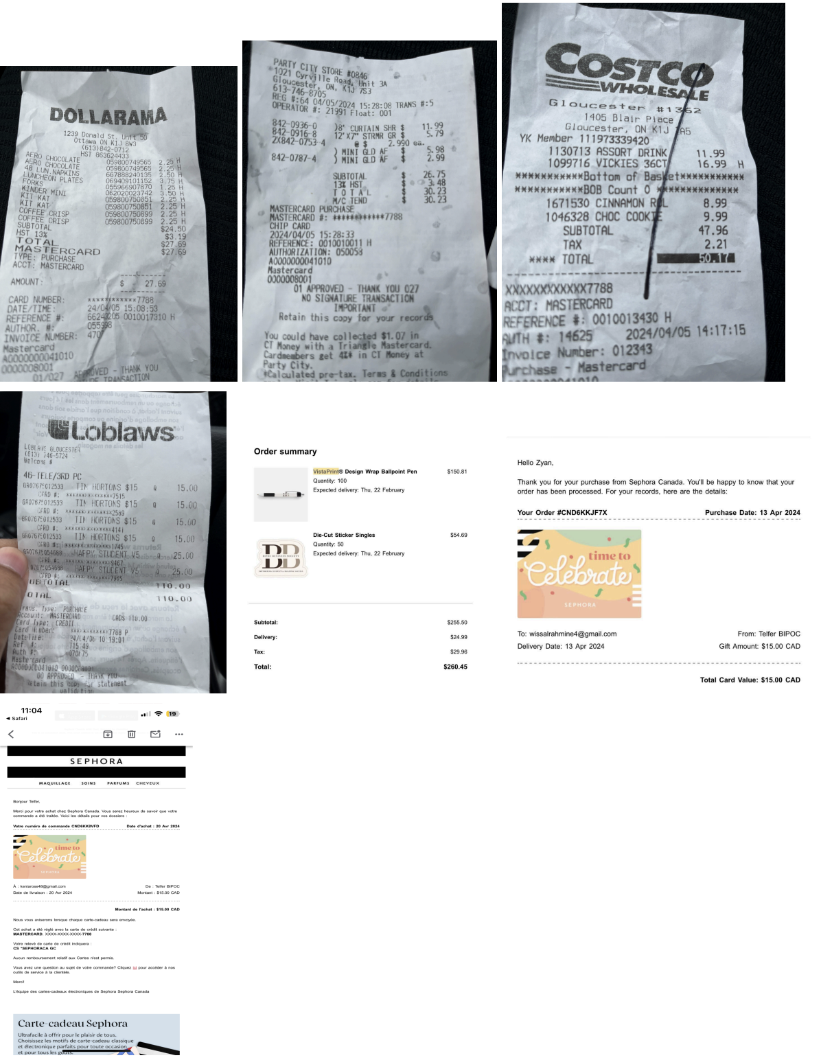

**Reason for Transaction:** Deloitte and Bingo Games Event Receipts

## E-Transfer Line on Bank Account:



Original Receipts:

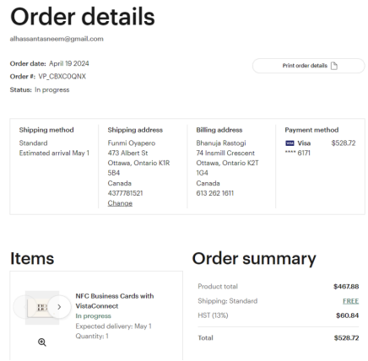

**Reason for Transaction:** Linkedin QR Code Receipt

Original Receipts:

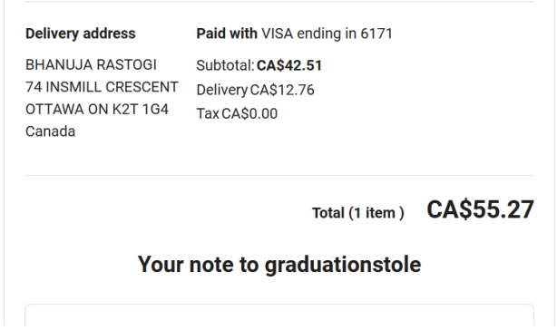

**Reason for Transaction:** Grad Sashes

## E-Transfer Line on Bank Account:



Original Receipts:

Reason for Transaction:

# 

# 

# 

# 

# 

# 

# 

# 

# 

# 

# 

# 

# 

# 

# 

# 

# 

# 

# 

# 

# 

# 

# 

# September 2024

## E-Transfer Line on Bank Account:



Original Receipts:

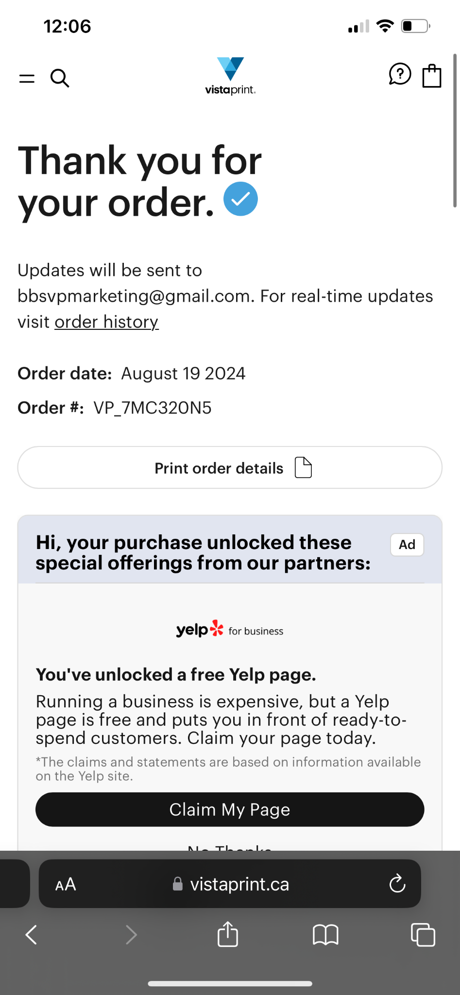

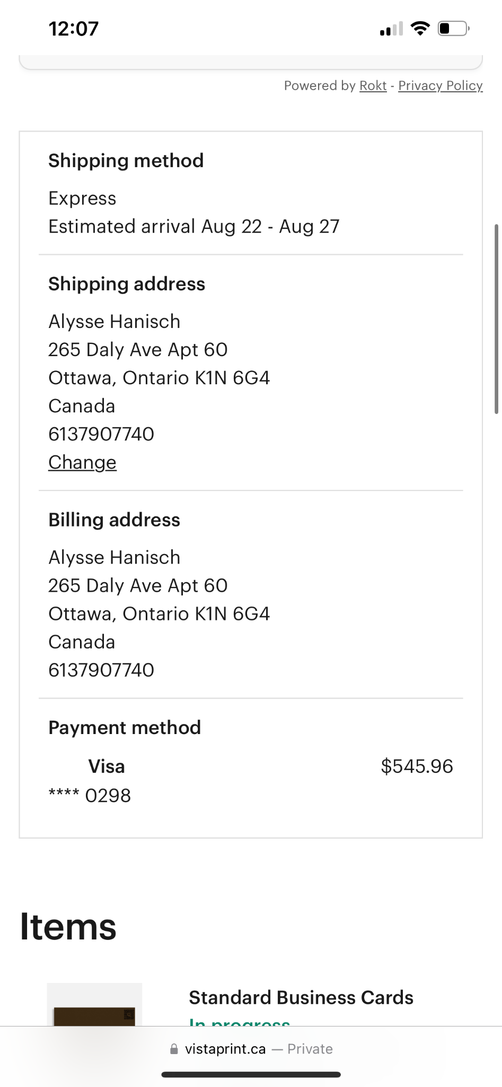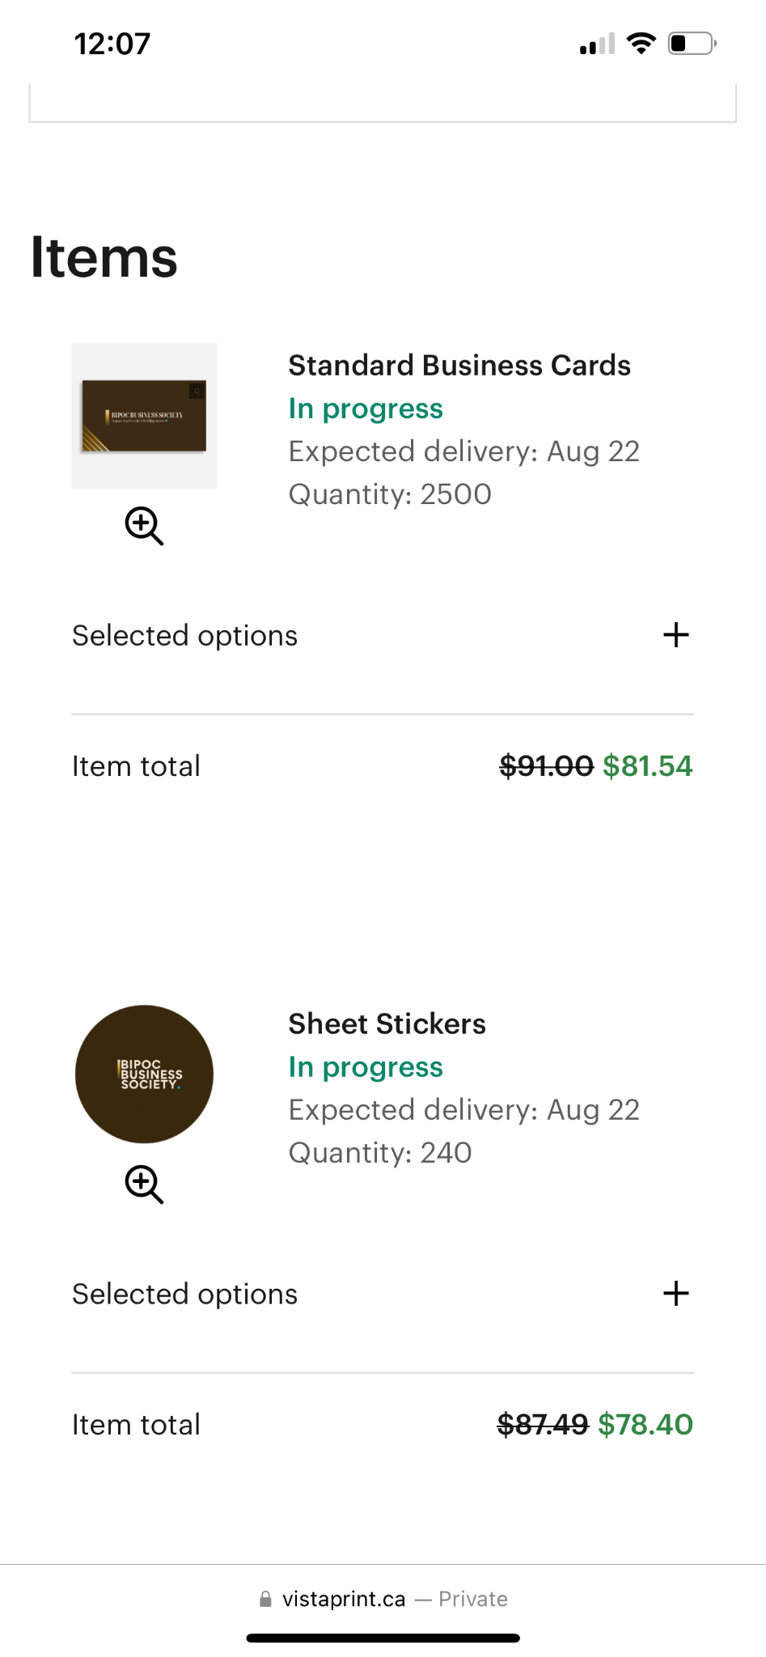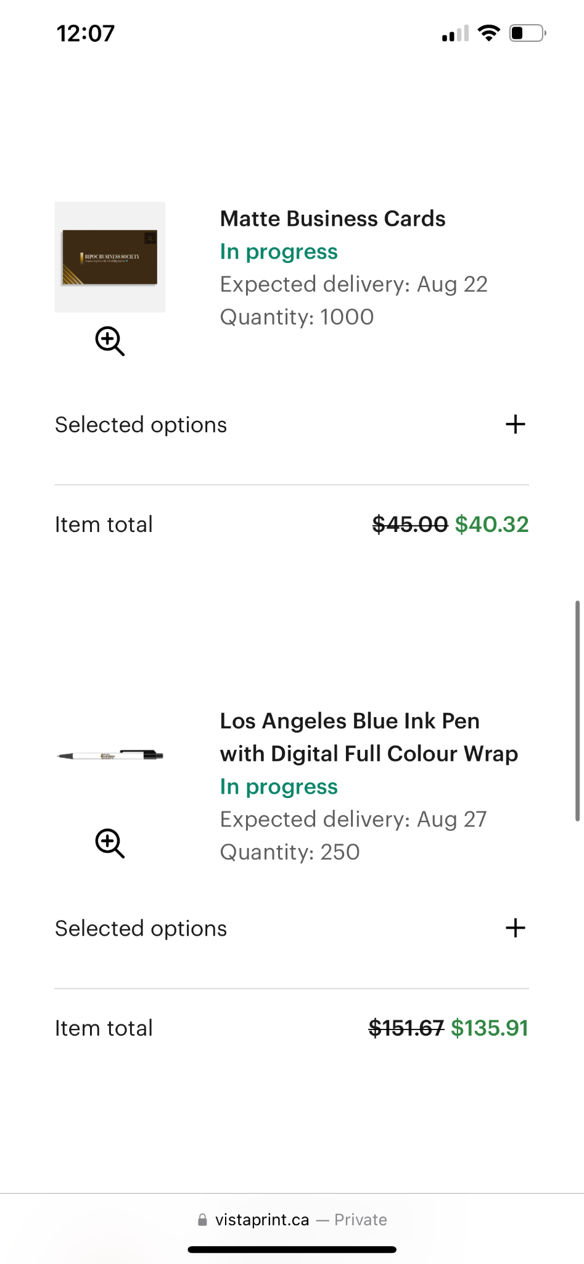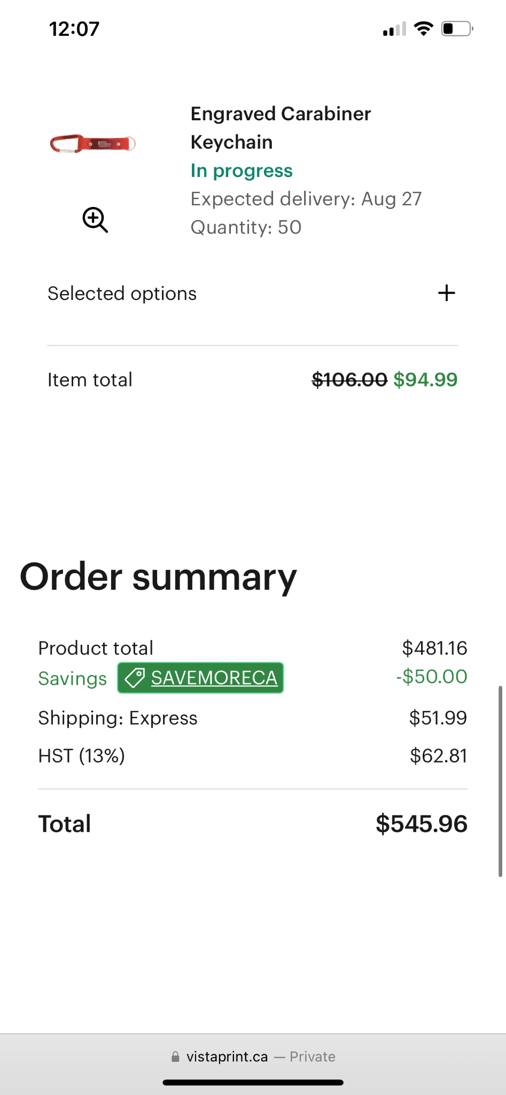

**Reason for Transaction:** Bill for Club Merch (101 Week Kits + Club Fair)

## 

## 

## 

## 

## E-Transfer Line on Bank Account:



Original Receipts:

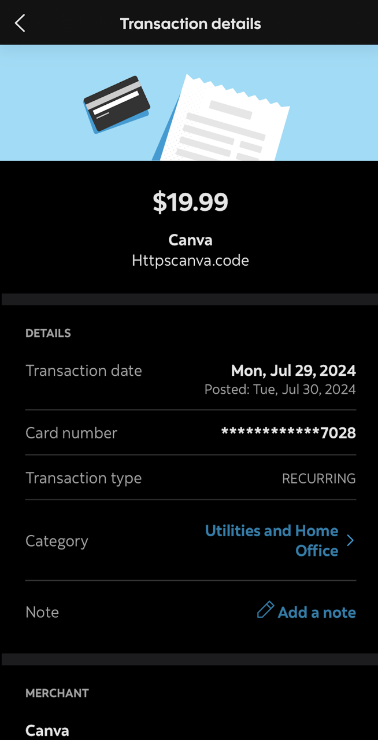

**Reason for Transaction:** Canva Subscription

## 

## 

## 

## 

## 

## 

## 

## 

## 

## 

## E-Transfer Line on Bank Account:



Original Receipts:

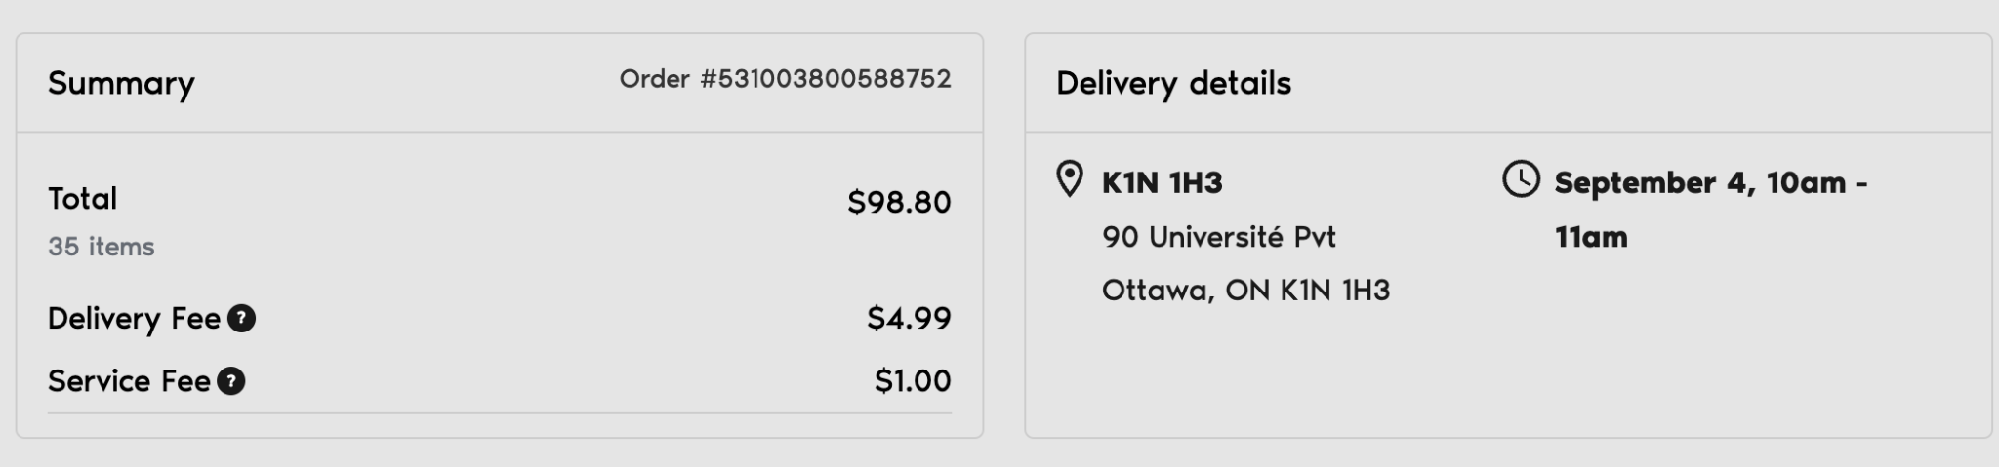

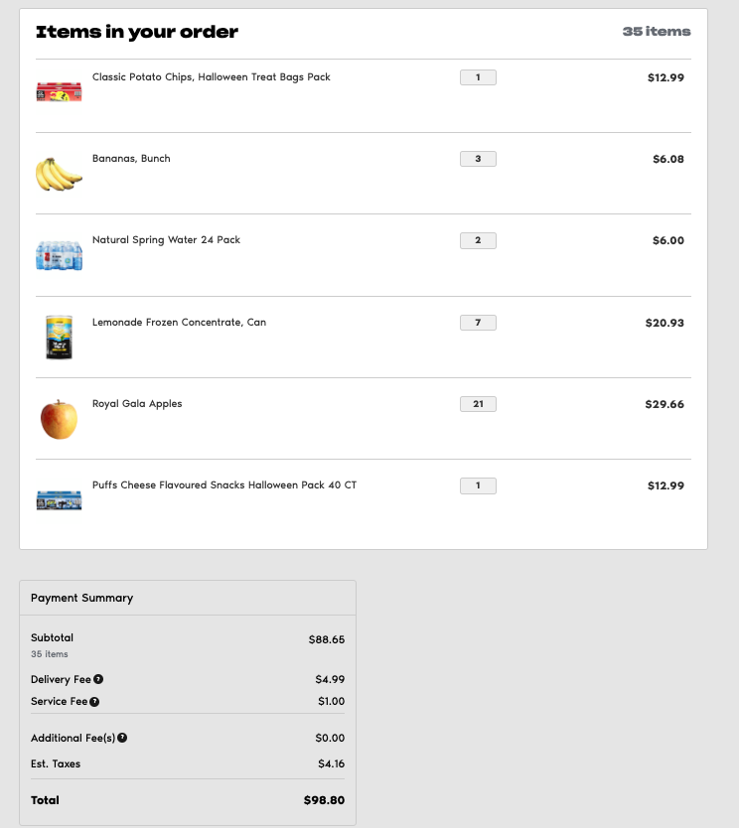

**Reason for Transaction:** Club Fair Food Order

## E-Transfer Line on Bank Account:



Original Receipts:

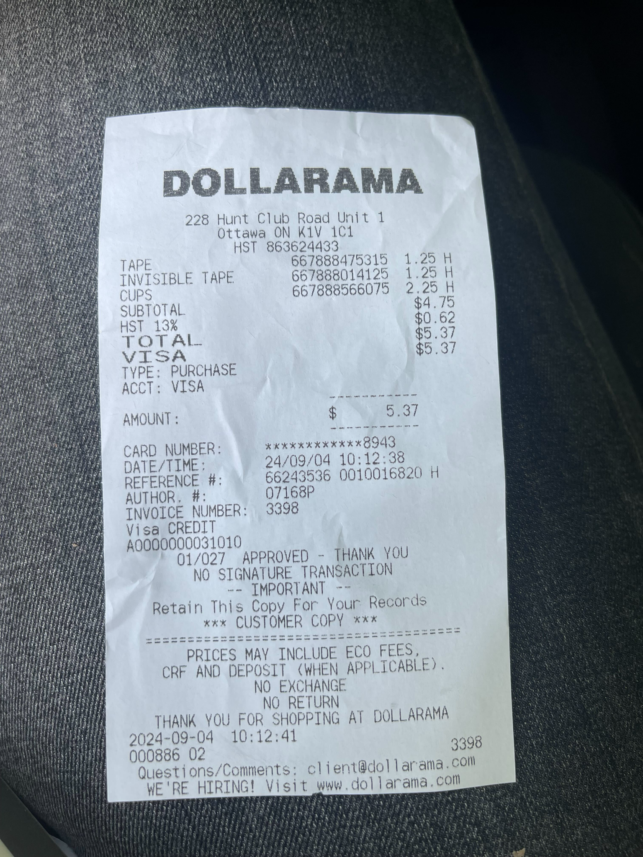

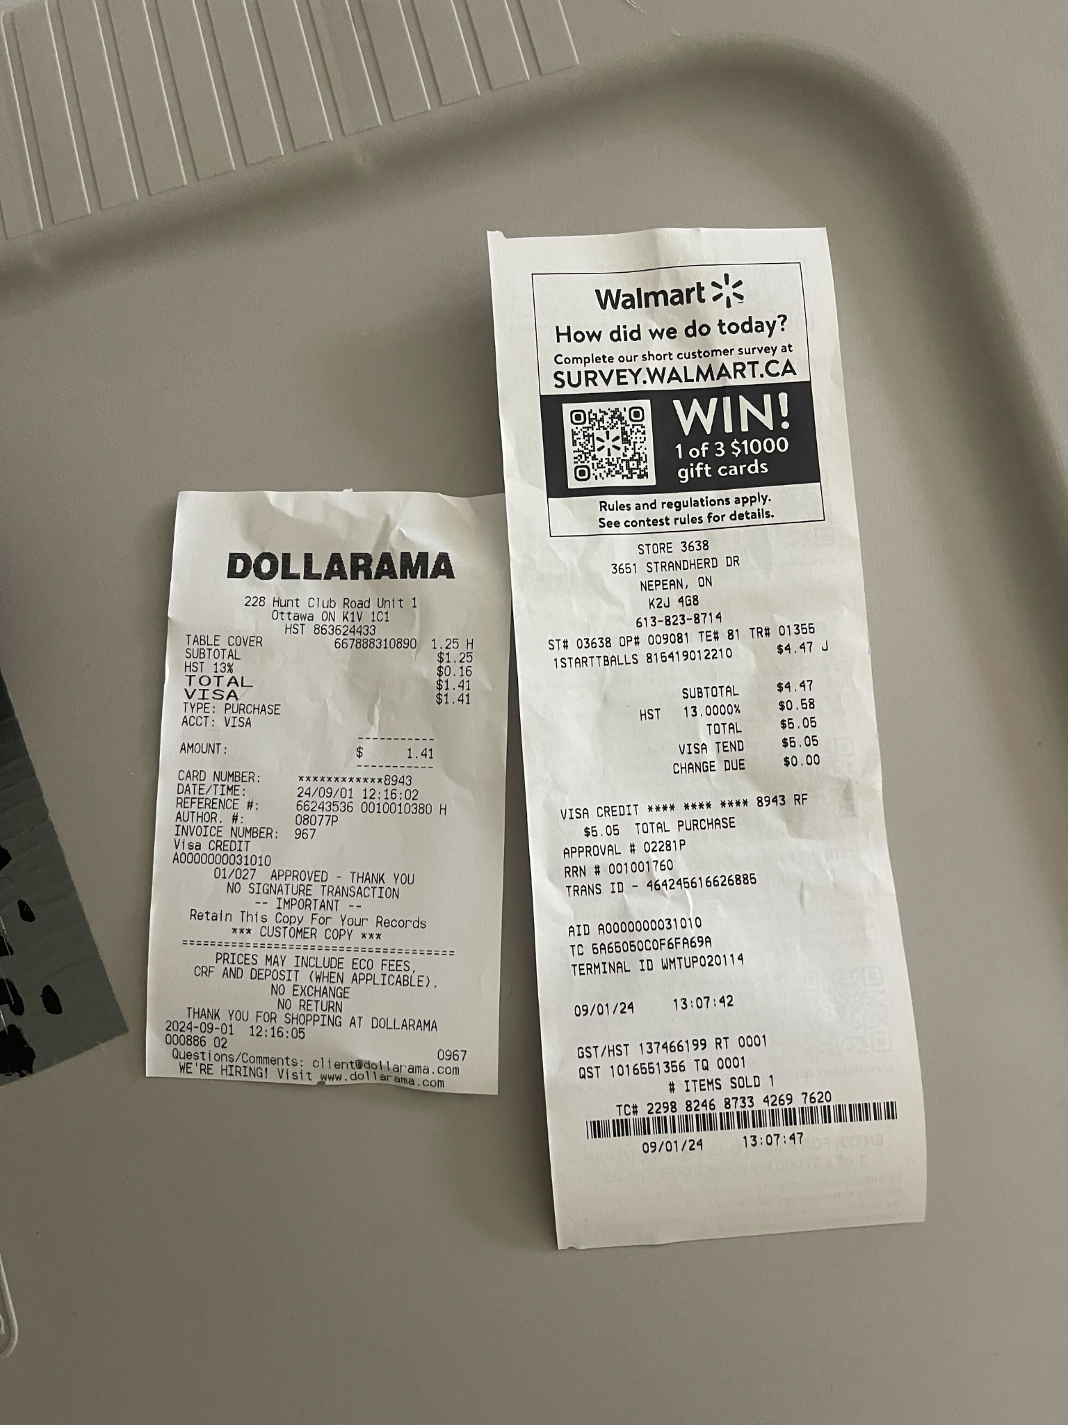

**Reason for Transaction:** Club Fair Expenses

## E-Transfer Line on Bank Account:



Original Receipts:

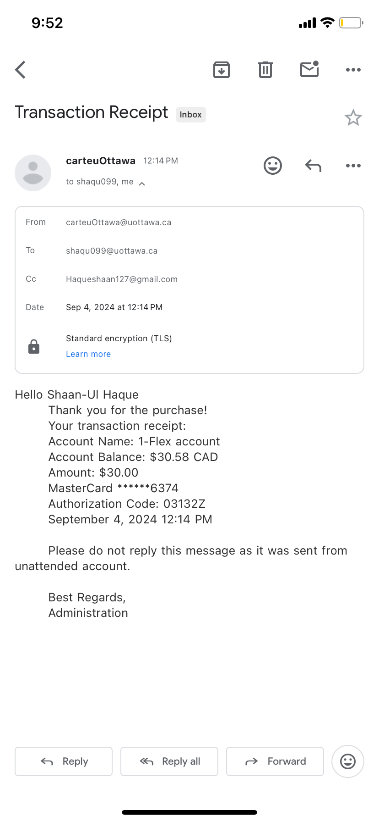

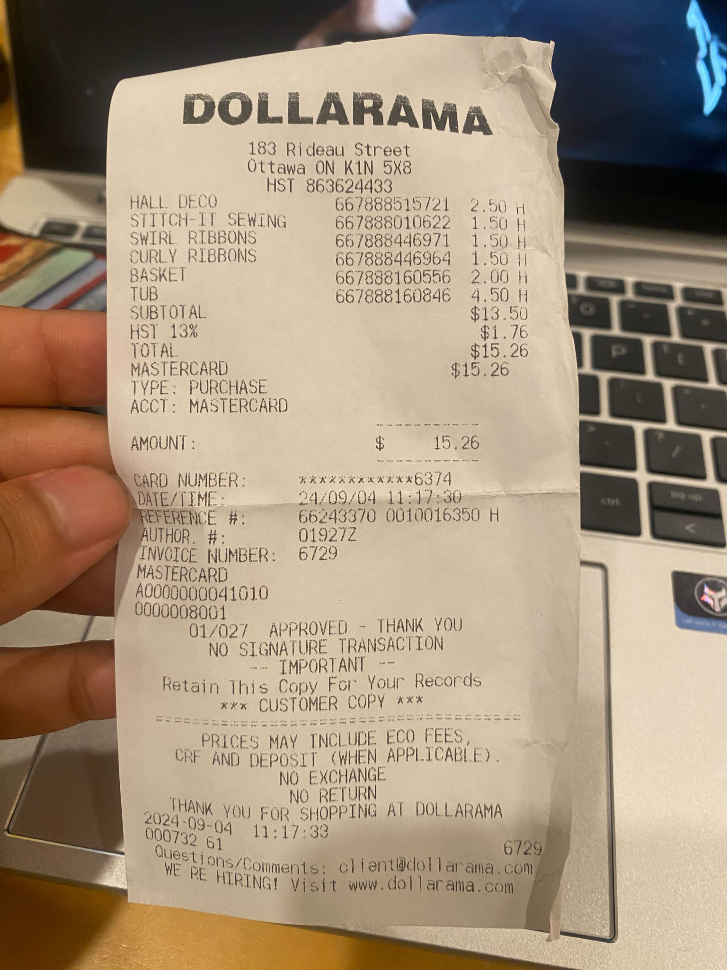

**Reason for Transaction:** Club Fair Expenses

## E-Transfer Line on Bank Account:

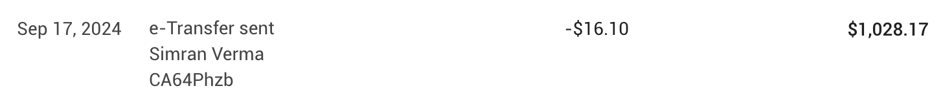

Original Receipts:

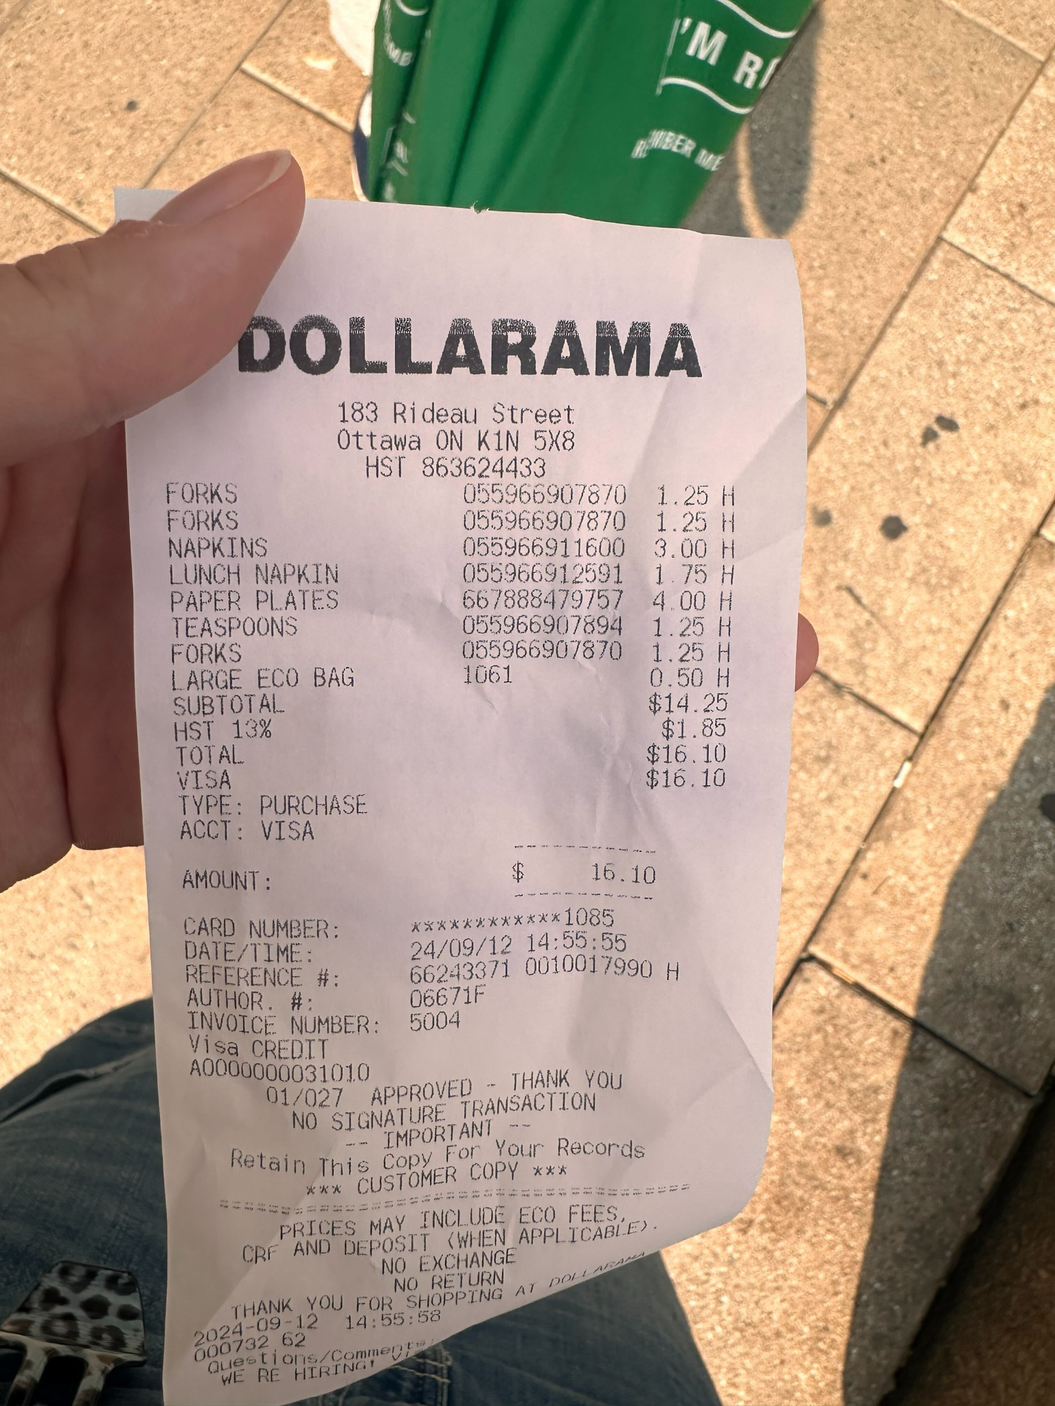

**Reason for Transaction:** BBQ Expenses

## E-Transfer Line on Bank Account:

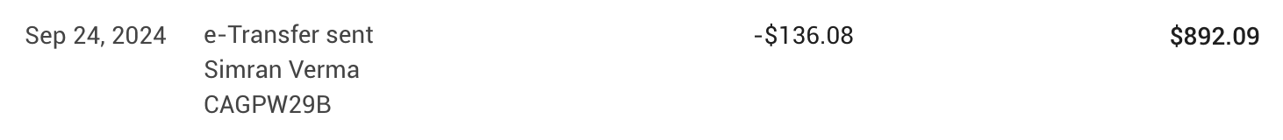

Original Receipts:

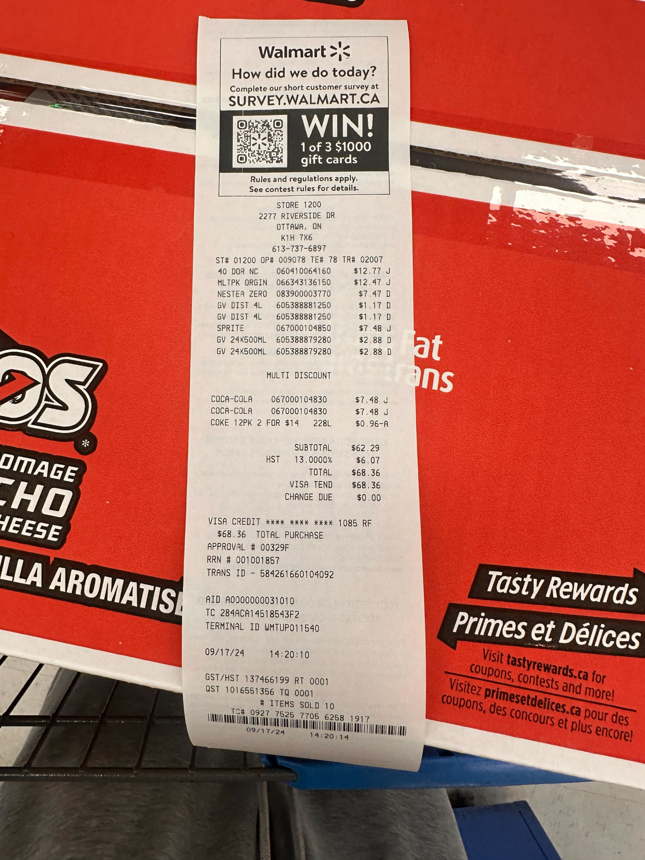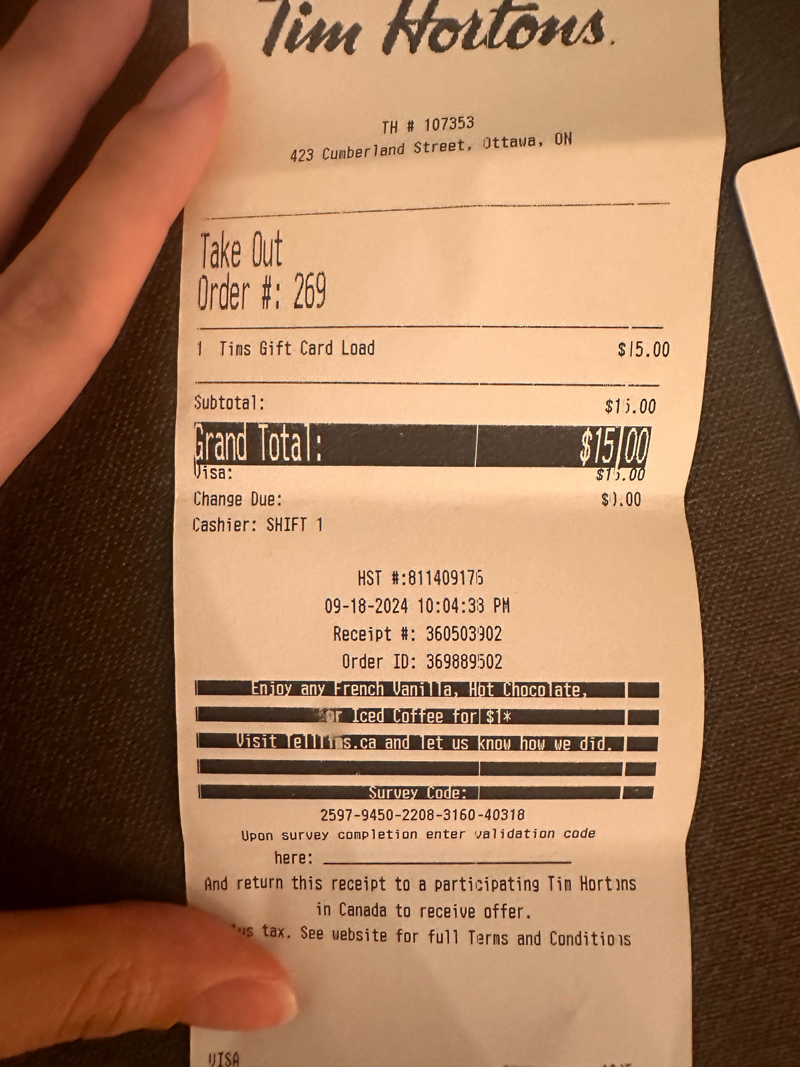

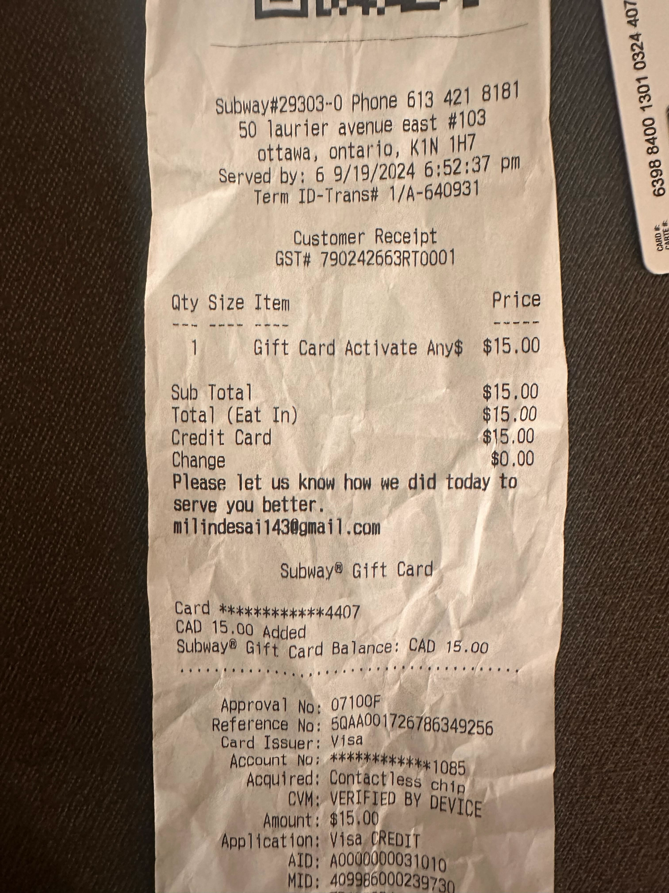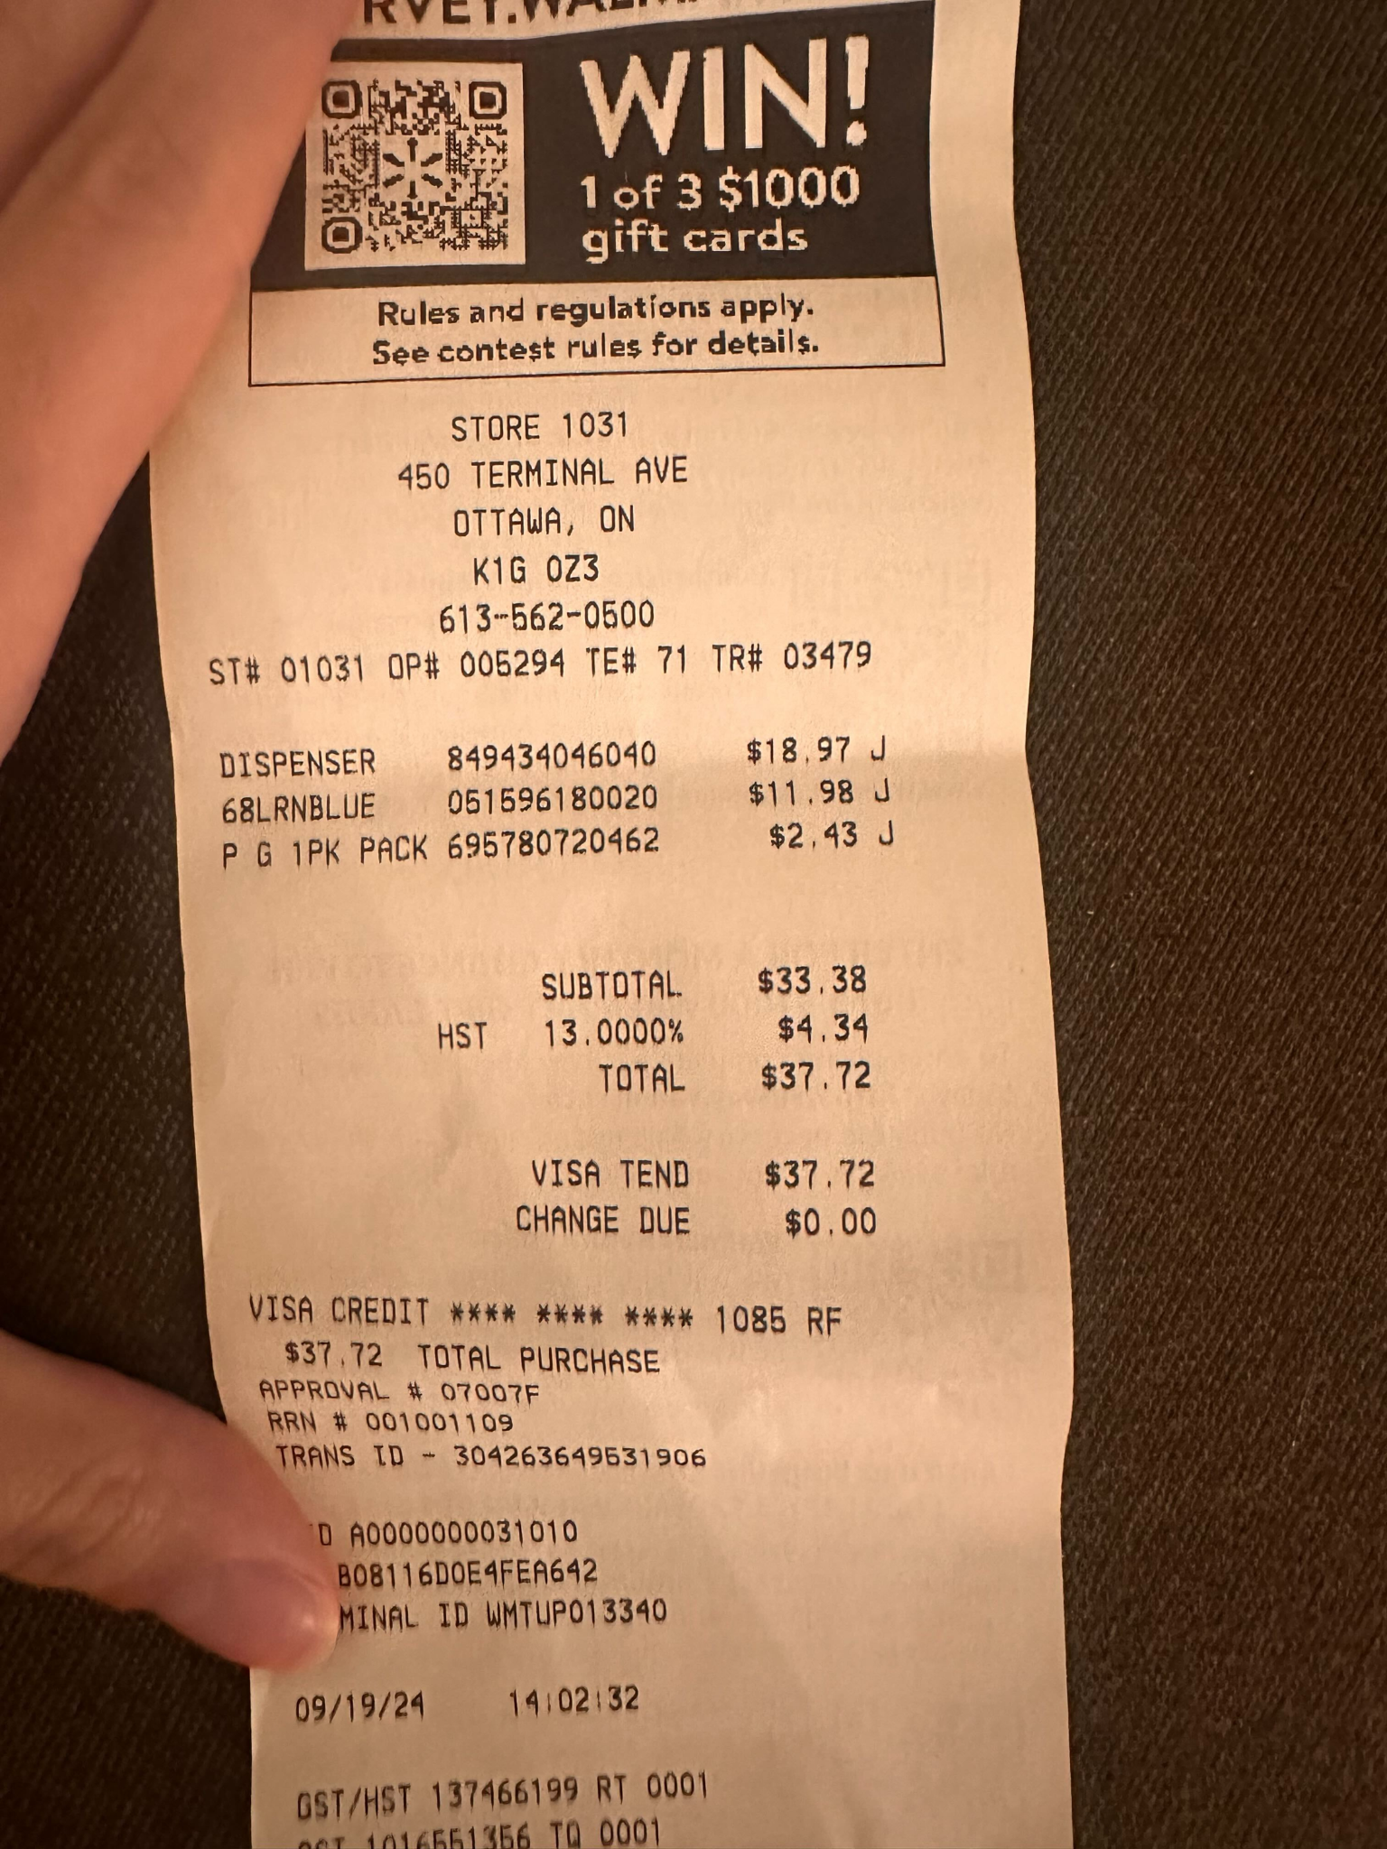

**Reason for Transaction:** Chips, gift cards from subway and tims going towards BBQ Expenses for Sept 20th → (68.36+15+15+37.72 = $136.08)

## E-Transfer Line on Bank Account:



Original Receipts:

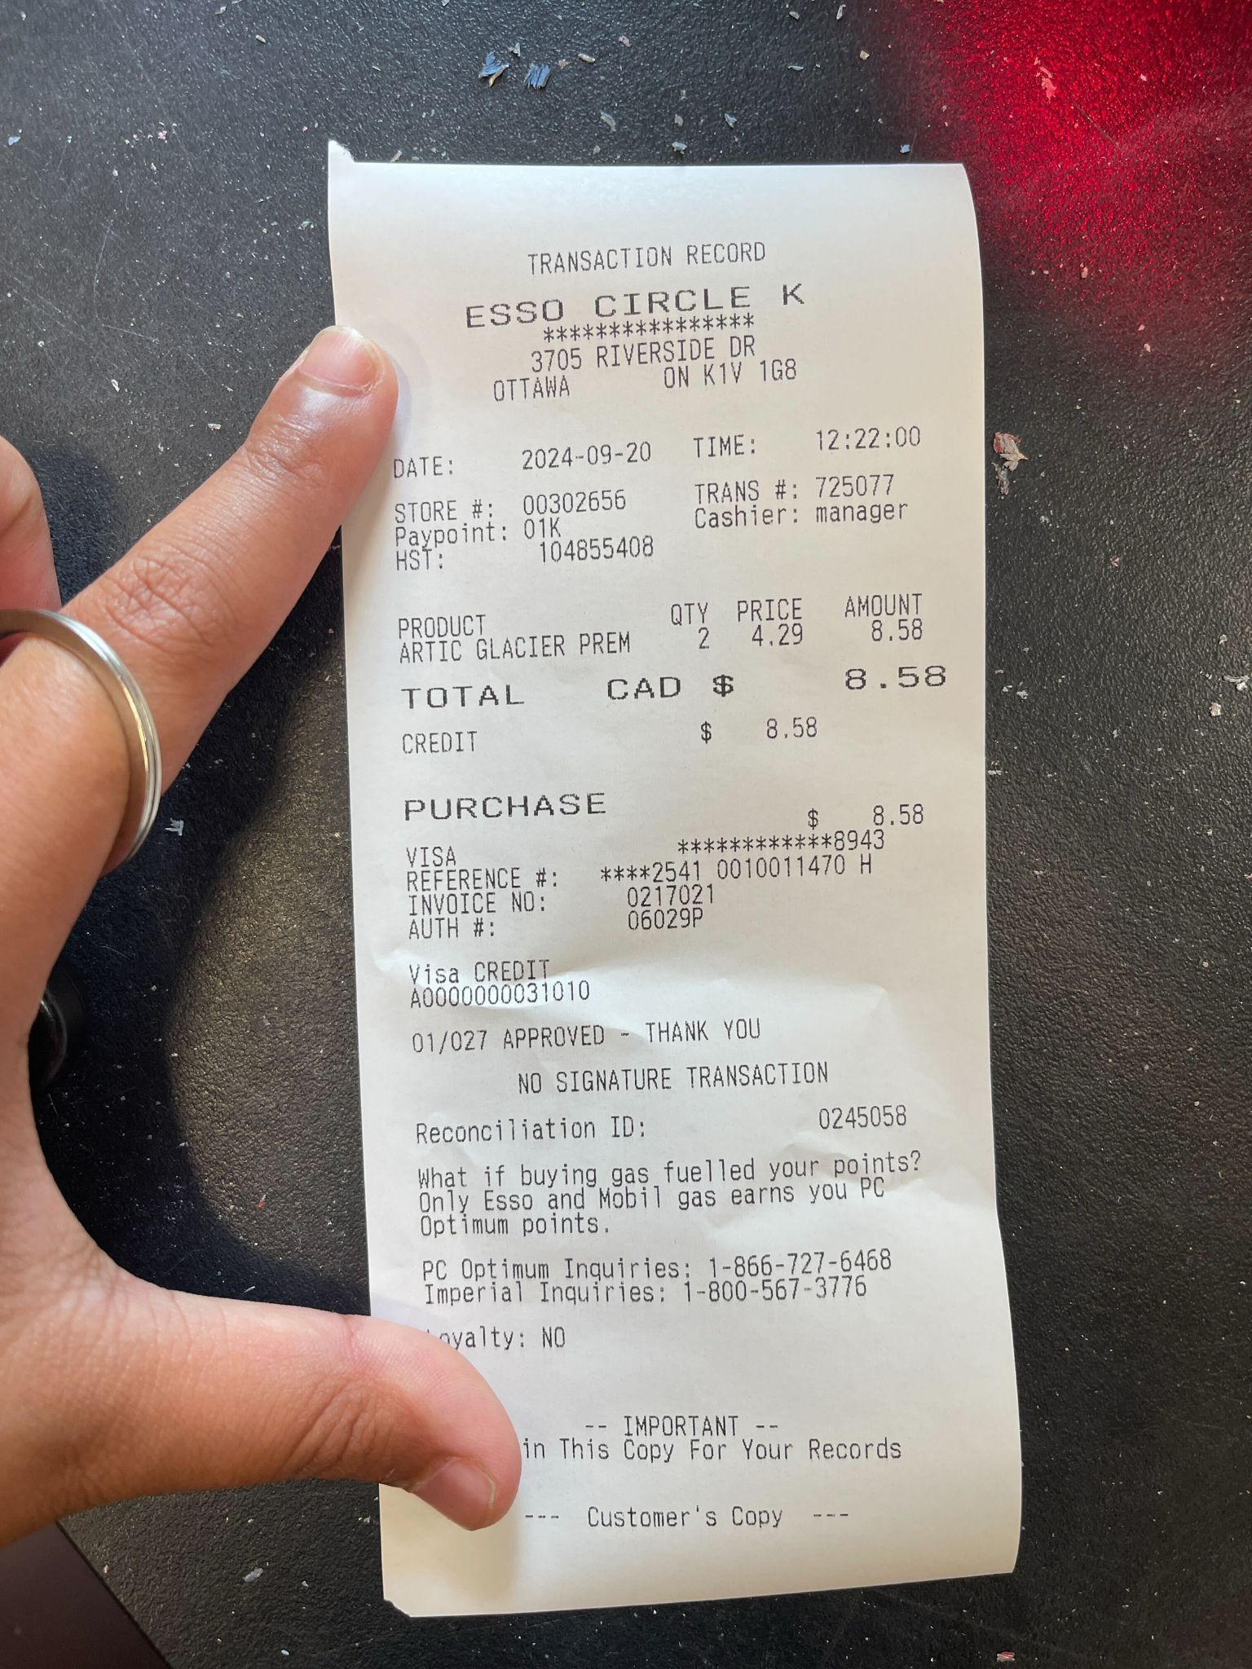

**Reason for Transaction:** Esso transaction going towards BBQ Expenses for Sept 20th

## E-Transfer Line on Bank Account:

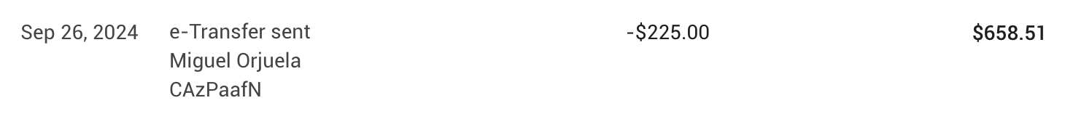

Original Receipts:

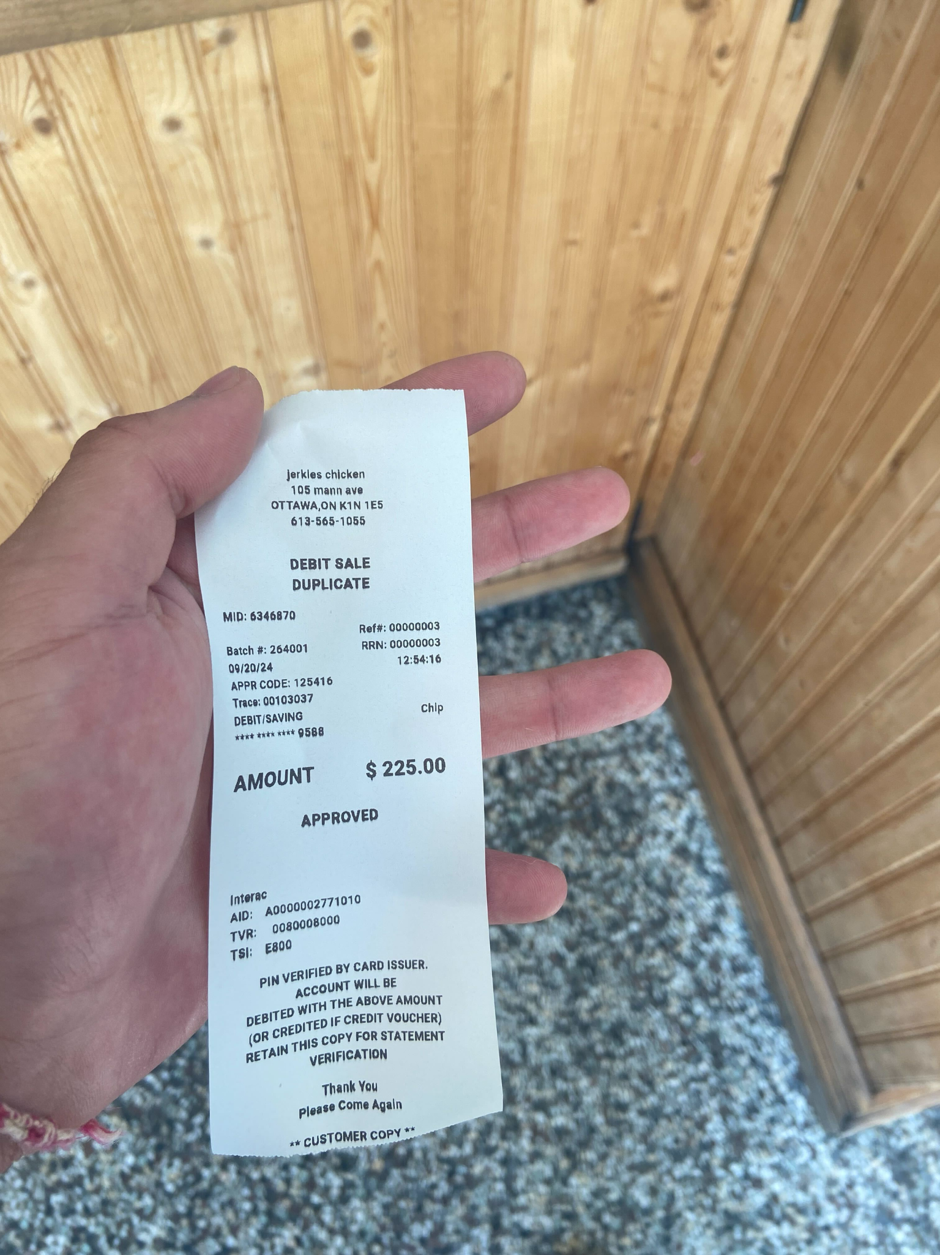

**Reason for Transaction:** Jerkie’s chicken going towards BBQ Expenses for Sept 20th

## E-Transfer Line on Bank Account:



Original Receipts:

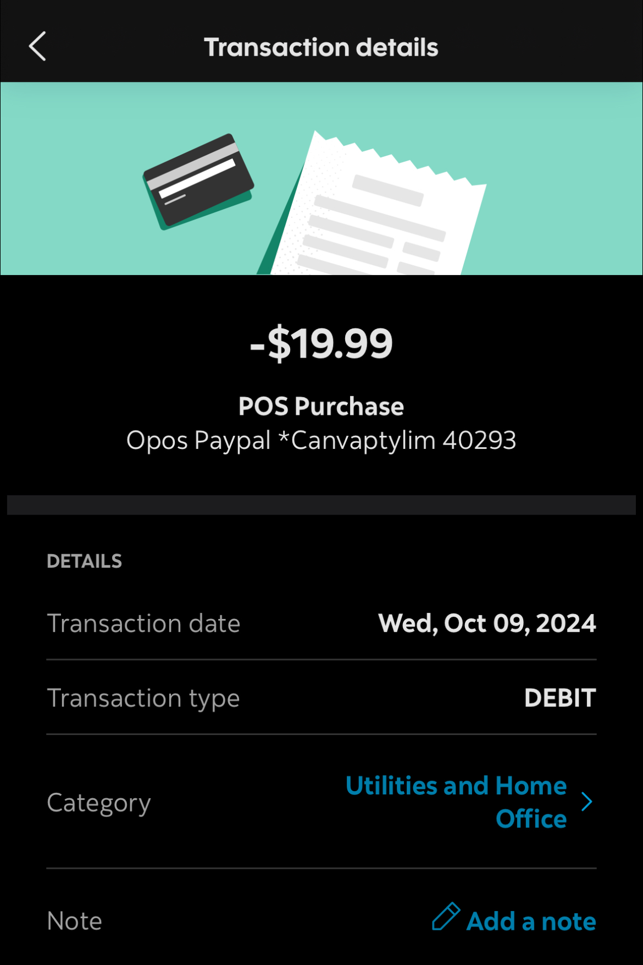

**Reason for Transaction:** Canva Bill made on October 9th

## E-Transfer Line on Bank Account:



(e-transfer sent to Miguel)

Original Receipts:

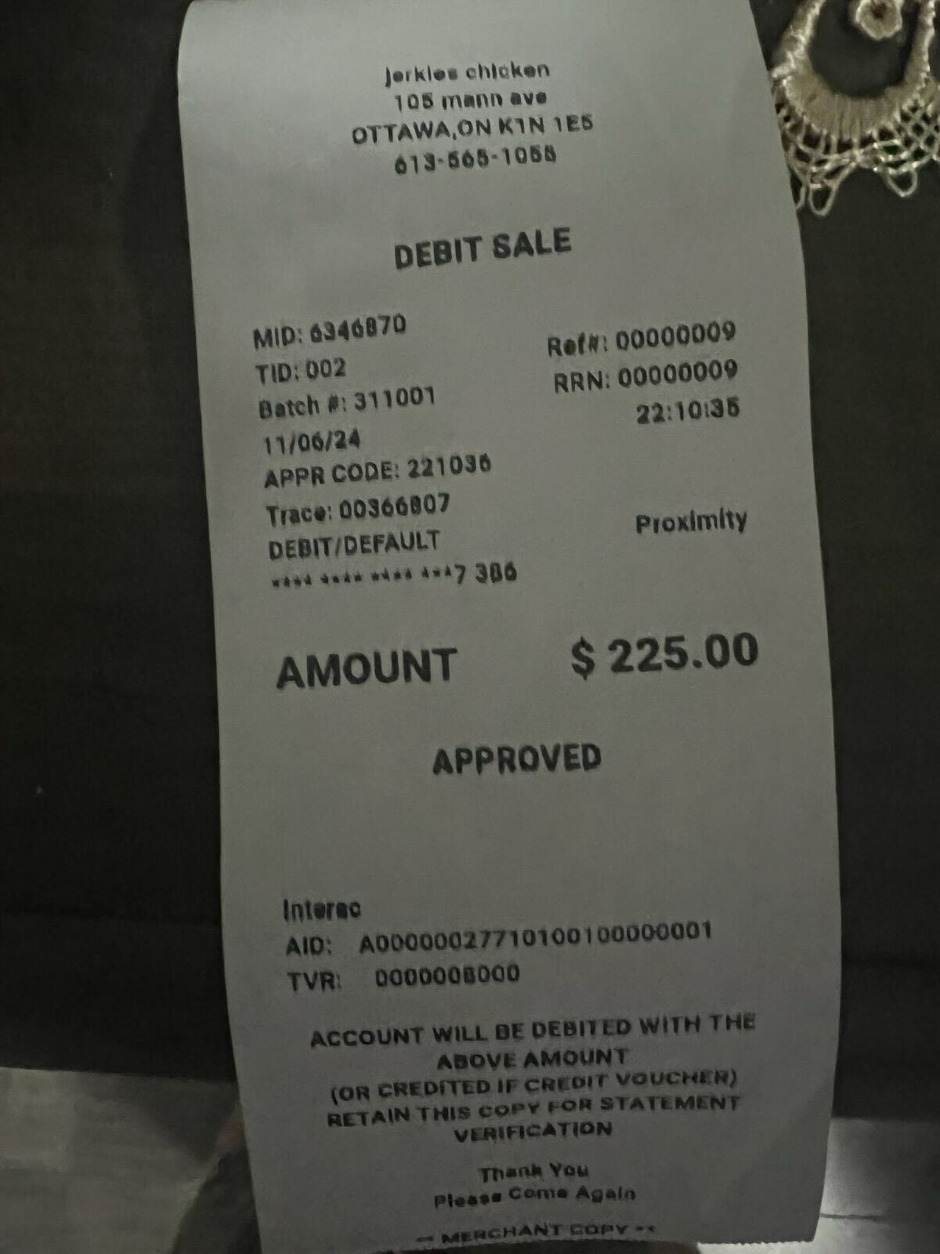

## E-Transfer Line on Bank Account:



Original Invoice:

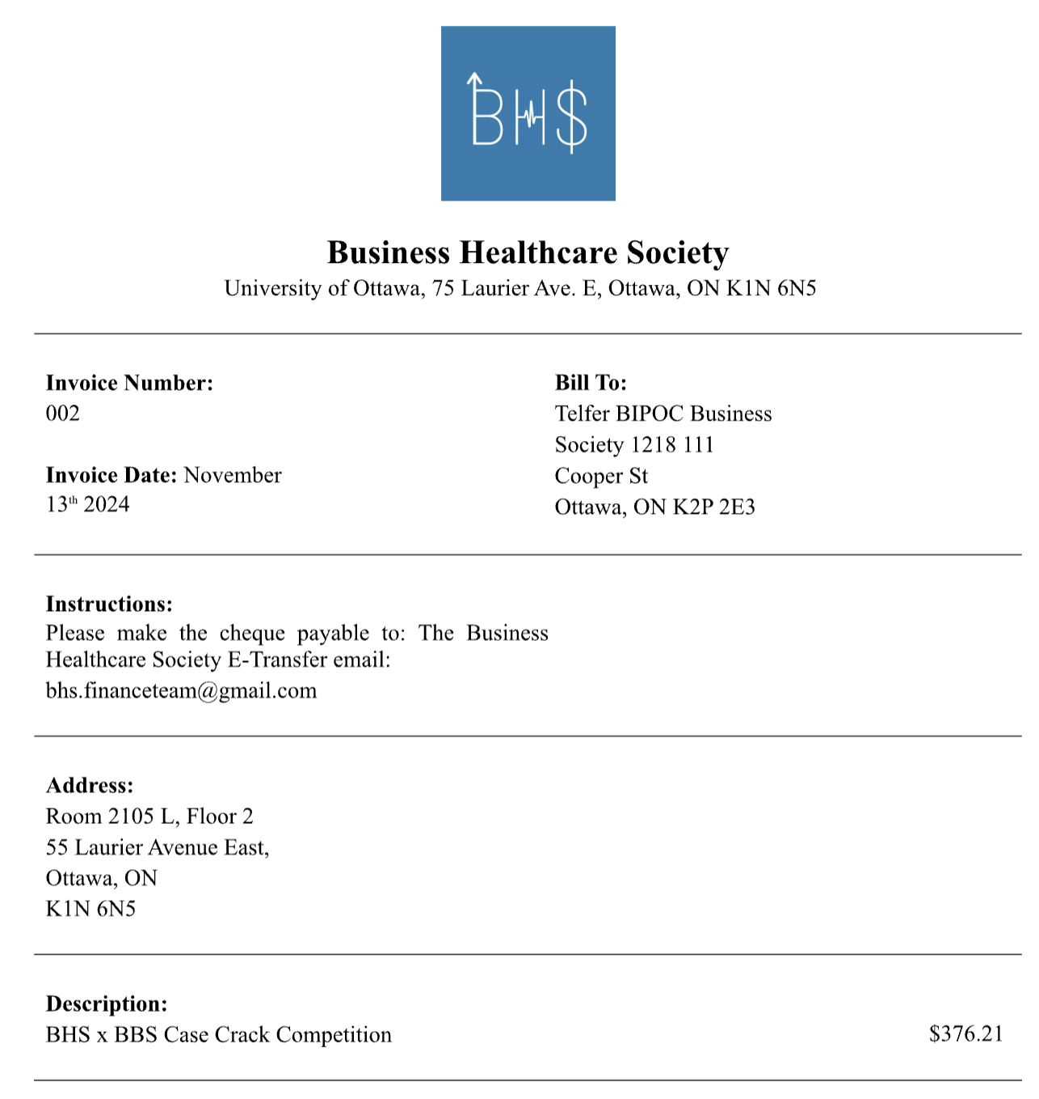

**Reason for Transaction:** BBS x BHS Case Competition Collab

## E-Transfer Line on Bank Account:



Original Receipts:

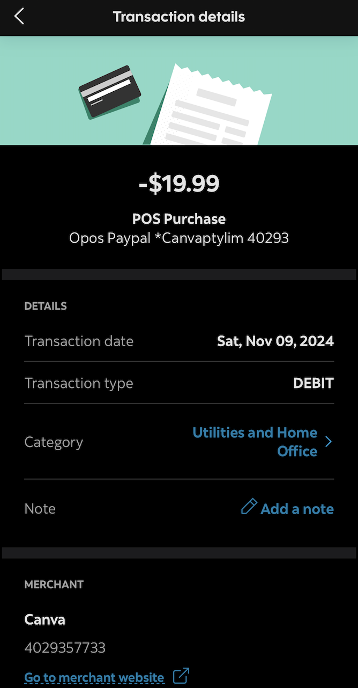

**Reason for Transaction:** Canva Bill made on November 9th

## 

## E-Transfer Line on Bank Account:

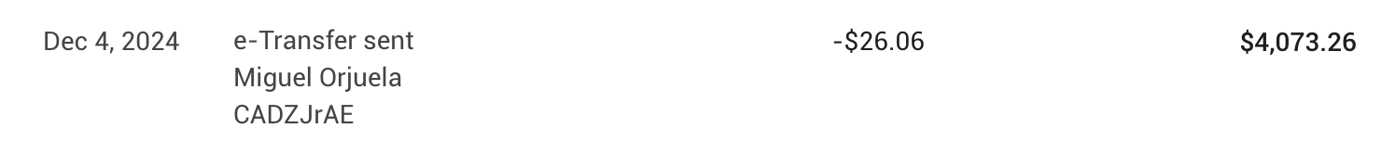

Original Receipts:

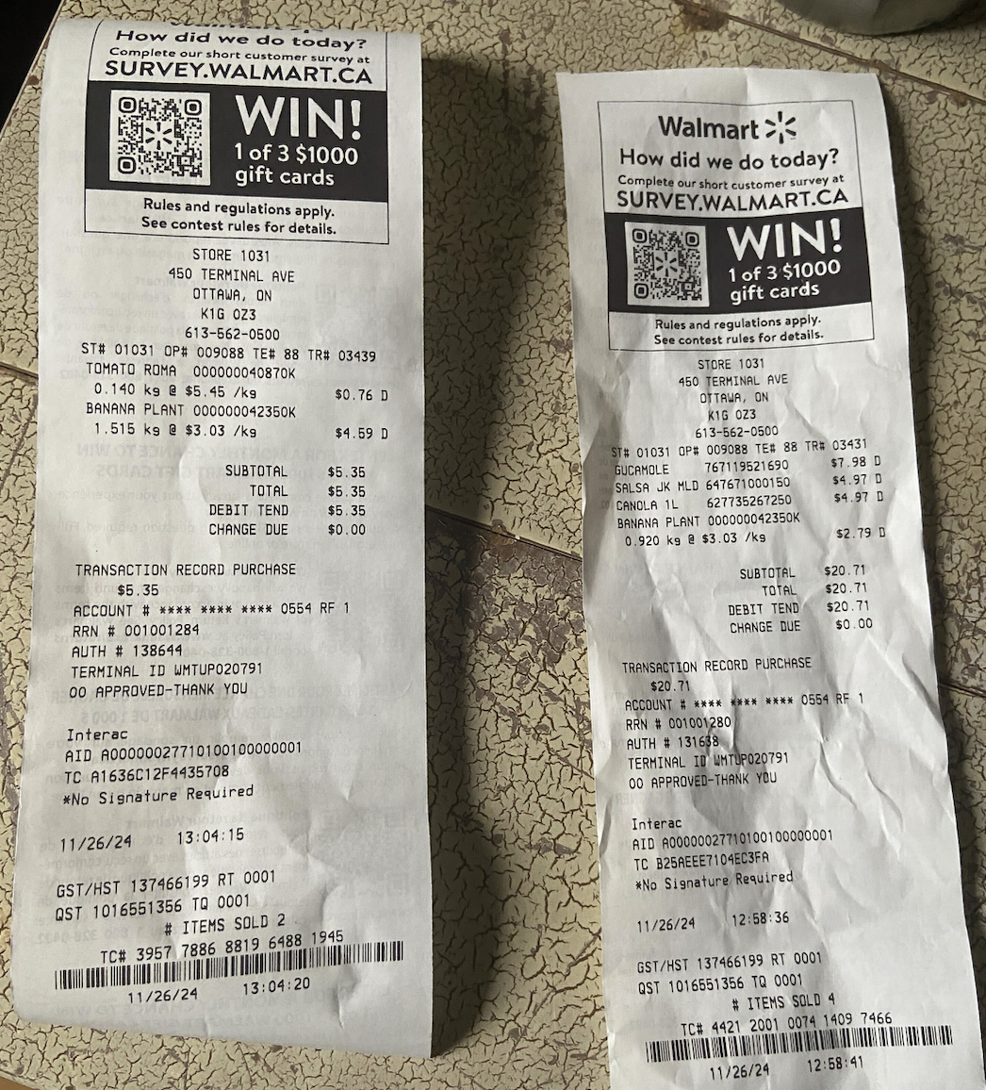

## E-Transfer Line on Bank Account:

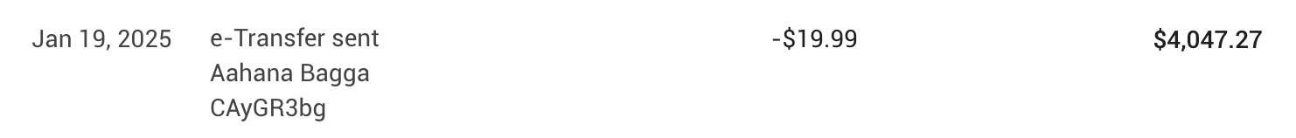

Original Receipts:

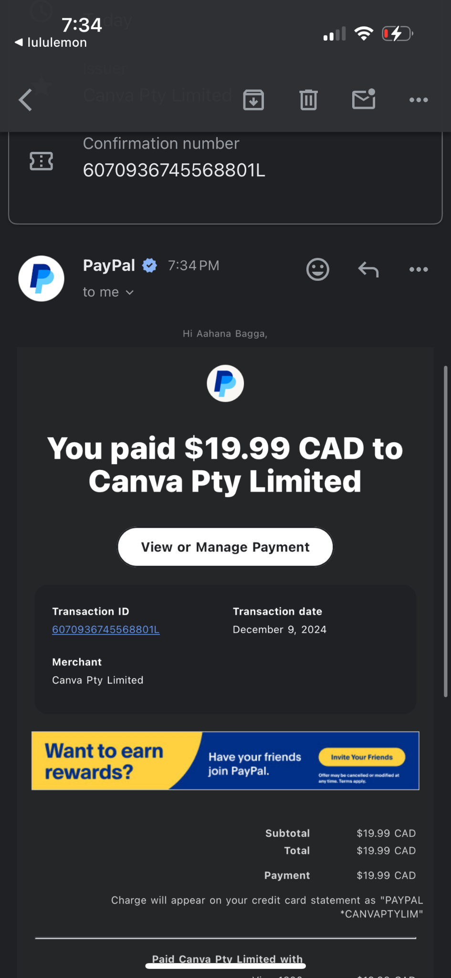

**Reason for Transaction:** Canva Bill made on December 9th

## E-Transfer Line on Bank Account:



Original Receipts:

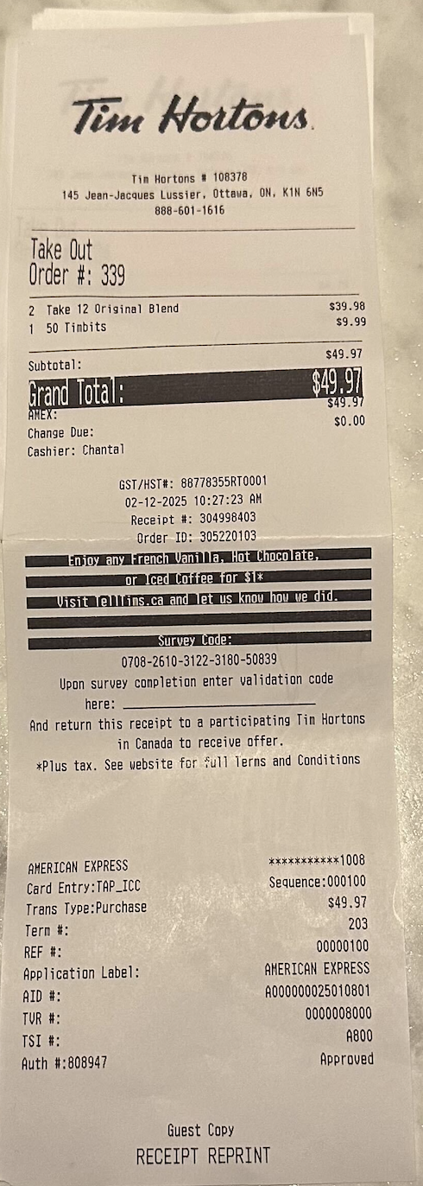

**Reason for Transaction:** Transport Canada Event Tim Hortons bill made on February 20th

## E-Transfer Line on Bank Account:



Original Receipts:

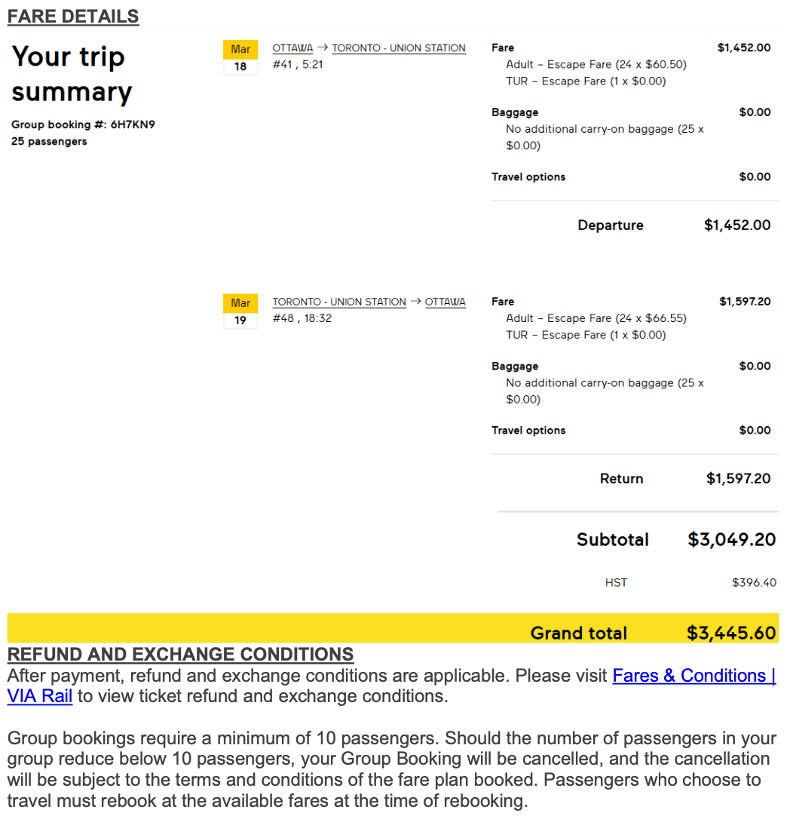

**Reason for Transaction:** VIA Rail Fare Purchase for 25 students for BIPOC Toronto Trip from March 18th-19th

## E-Transfer Line on Bank Account:

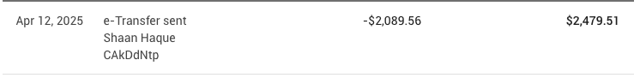

Original Receipts:

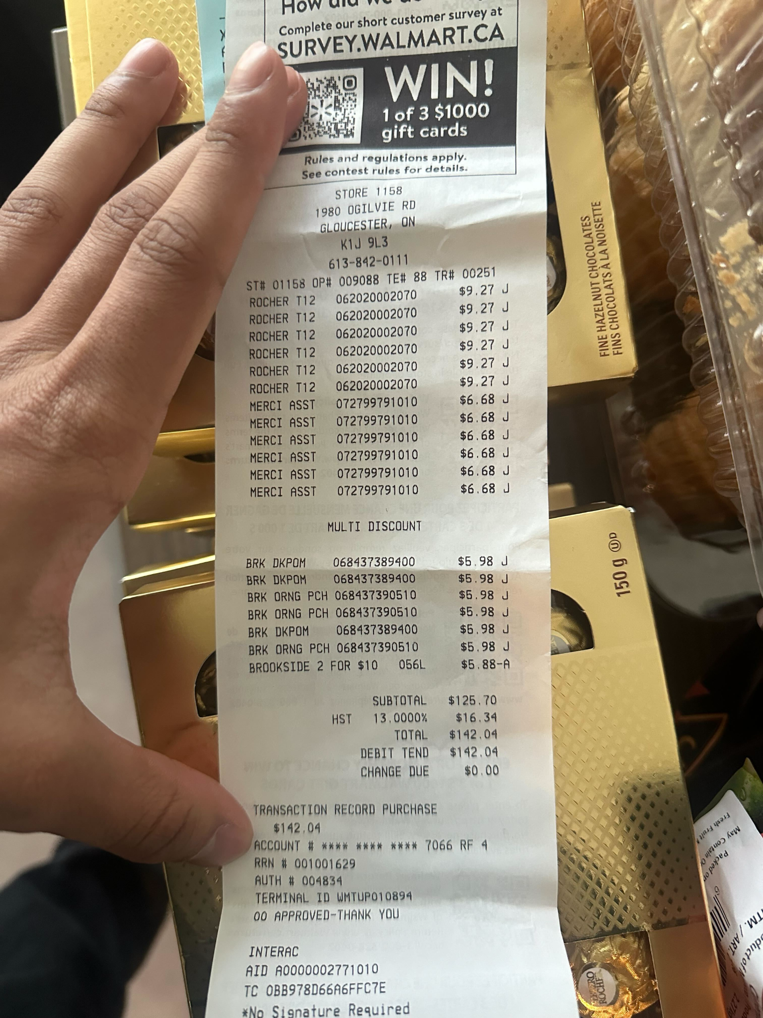

**Reason for Transaction:** Shaan’s Purchase towards BIPOC Toronto Trip from March 18th-19th

## E-Transfer Line on Bank Account:



Original Receipts:

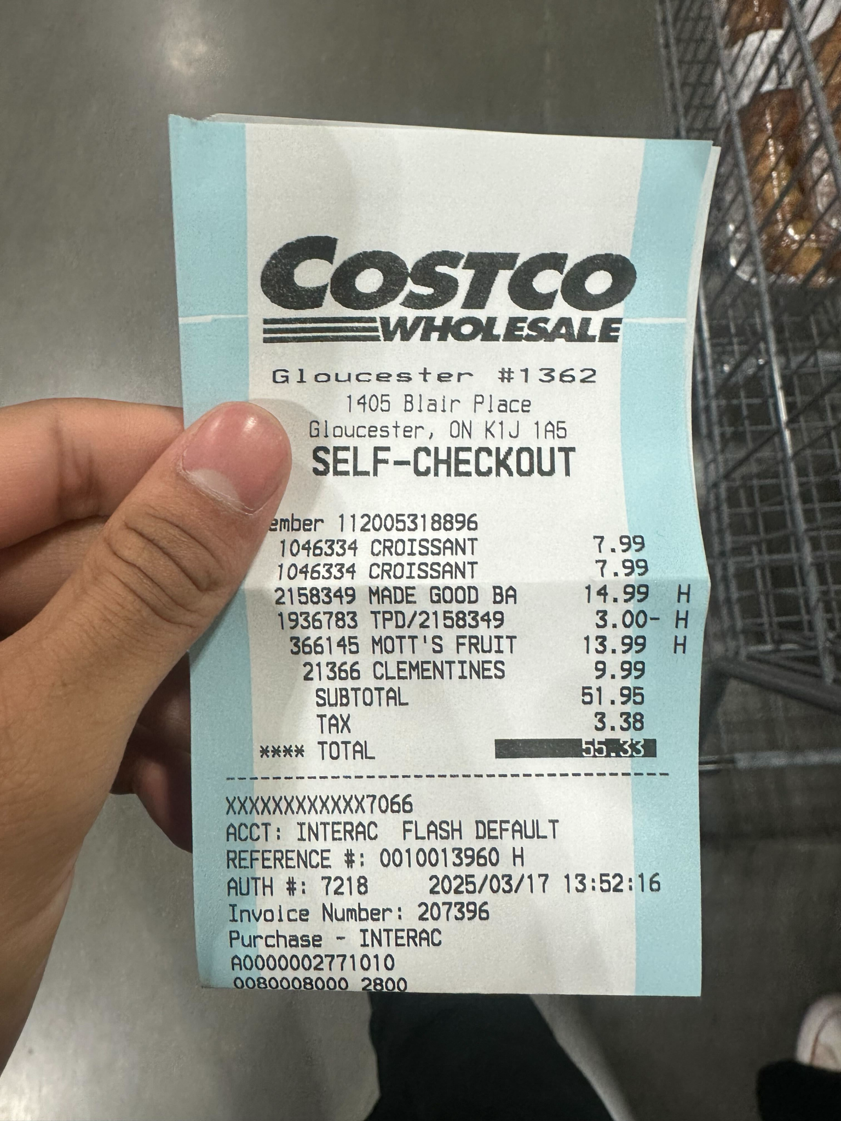

**Reason for Transaction:** Shaan’s food purchase towards BIPOC Toronto Trip from March 18th-19th

## 

## 

## 

## E-Transfer Line on Bank Account:



Original Receipts

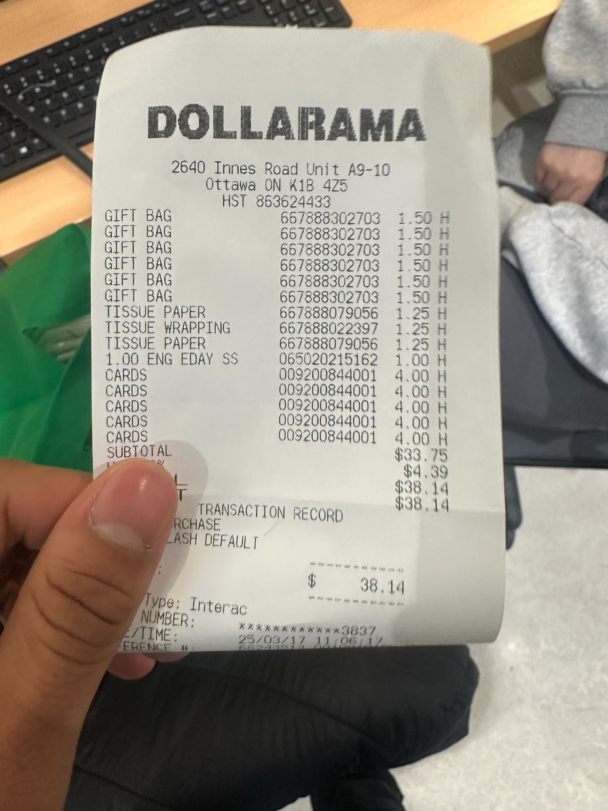

**Reason for Transaction:** Shaan’s gift card purchase for recruiters towards BIPOC Toronto Trip from March 18th-19th

## E-Transfer Line on Bank Account:



Original Receipts:

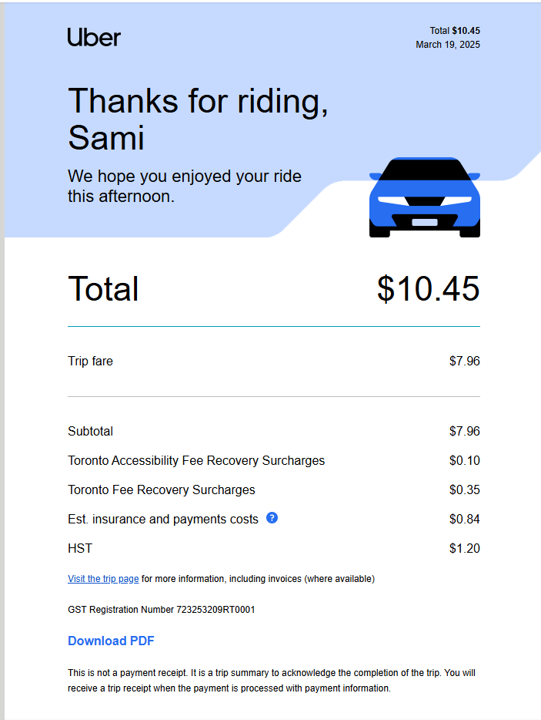

**Reason for Transaction:** Shaan’s Uber fee to pickup poulet rouge sponsor towards BIPOC Toronto Trip from March 18th-19th

## E-Transfer Line on Bank Account:



Original Receipts:

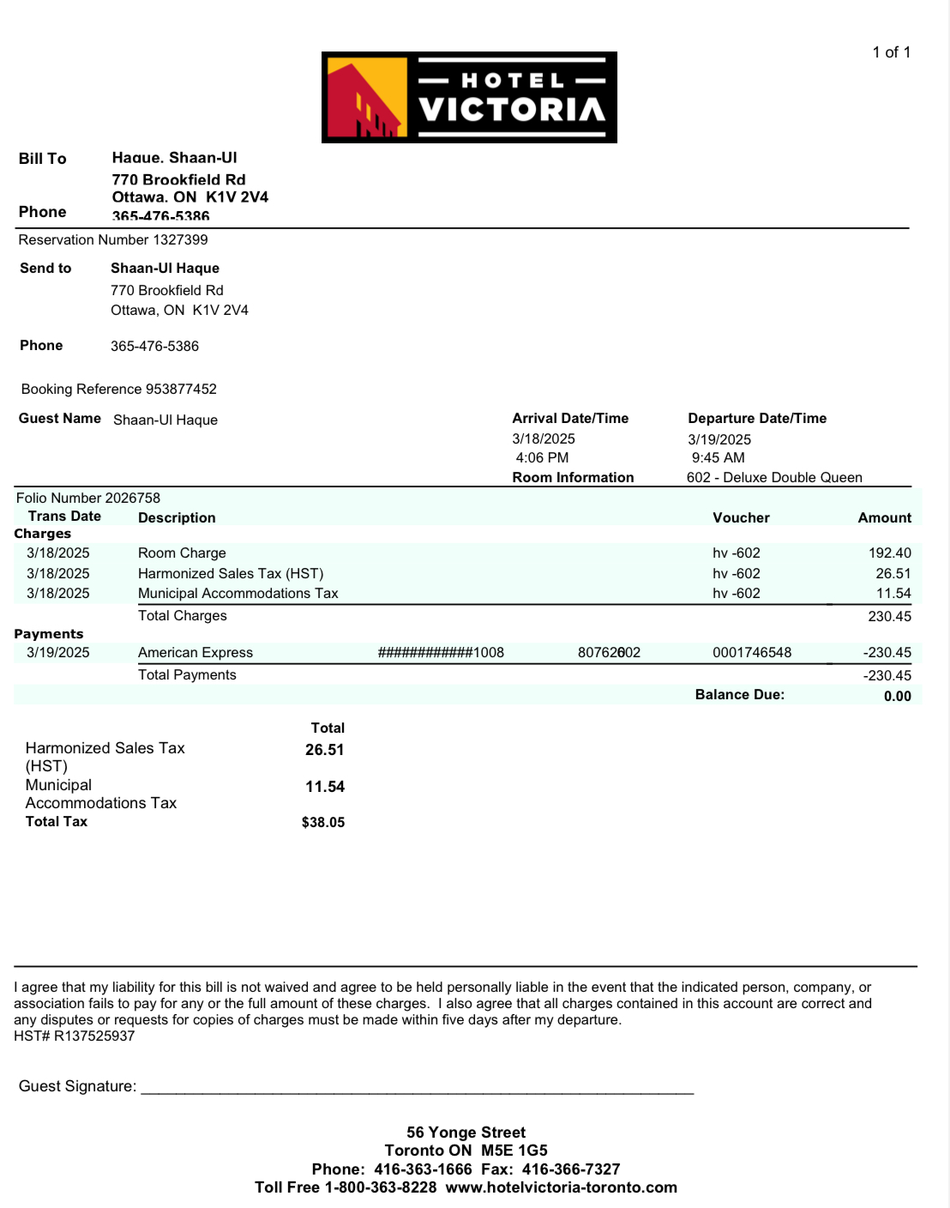

**Reason for Transaction:** Shaan’s hotel room purchase towards BIPOC Toronto Trip from March 18th-19th

## E-Transfer Line on Bank Account:



Original Receipts:

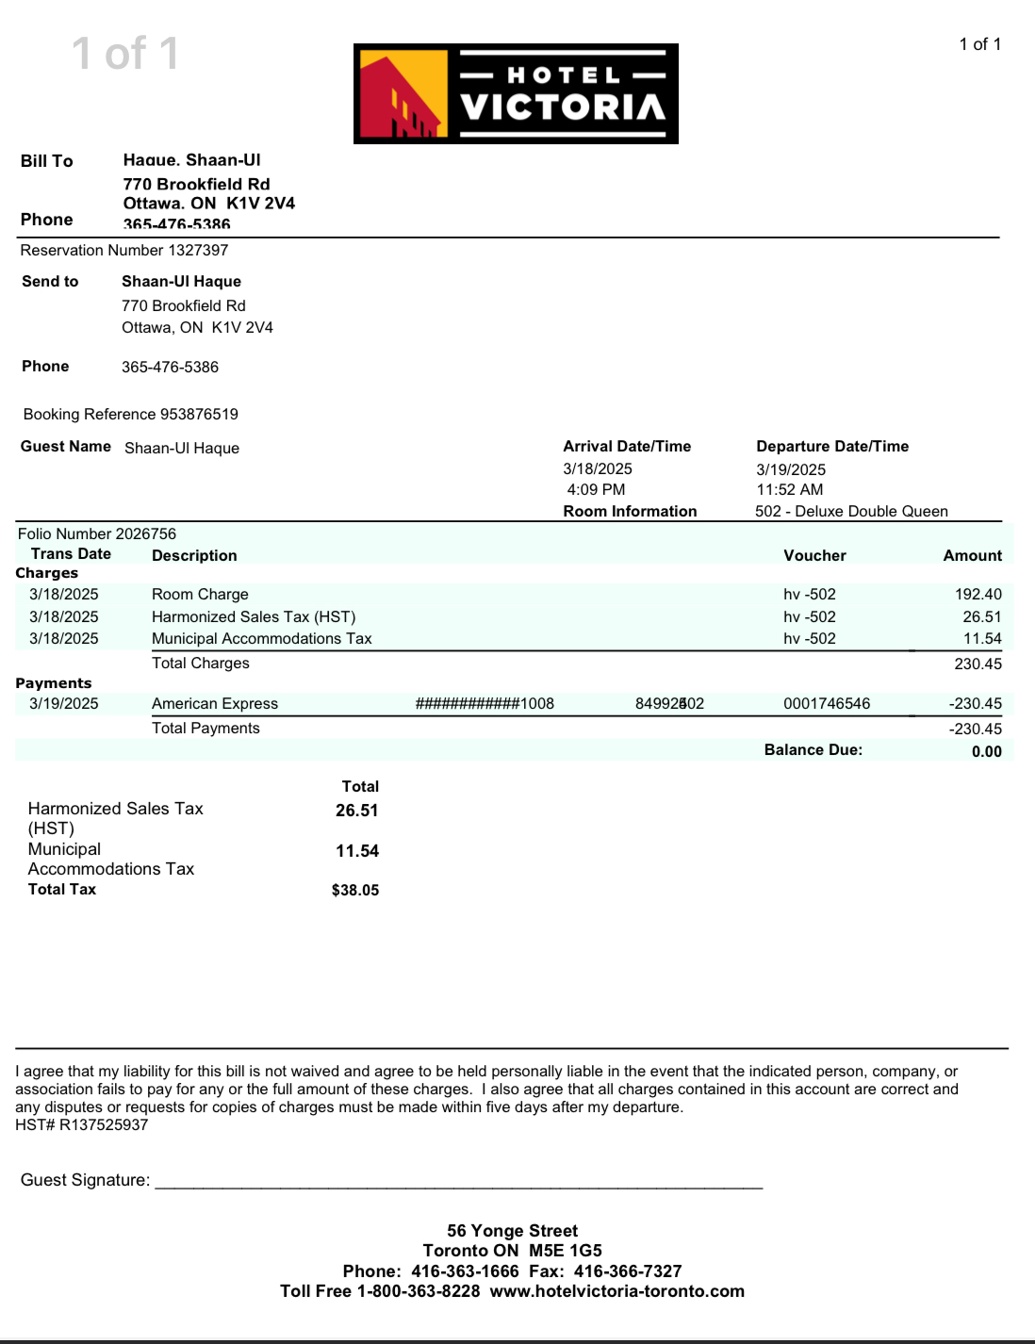

**Reason for Transaction:** Shaan’s hotel room purchase towards BIPOC Toronto Trip from March 18th-19th

## E-Transfer Line on Bank Account:



Original Receipts:

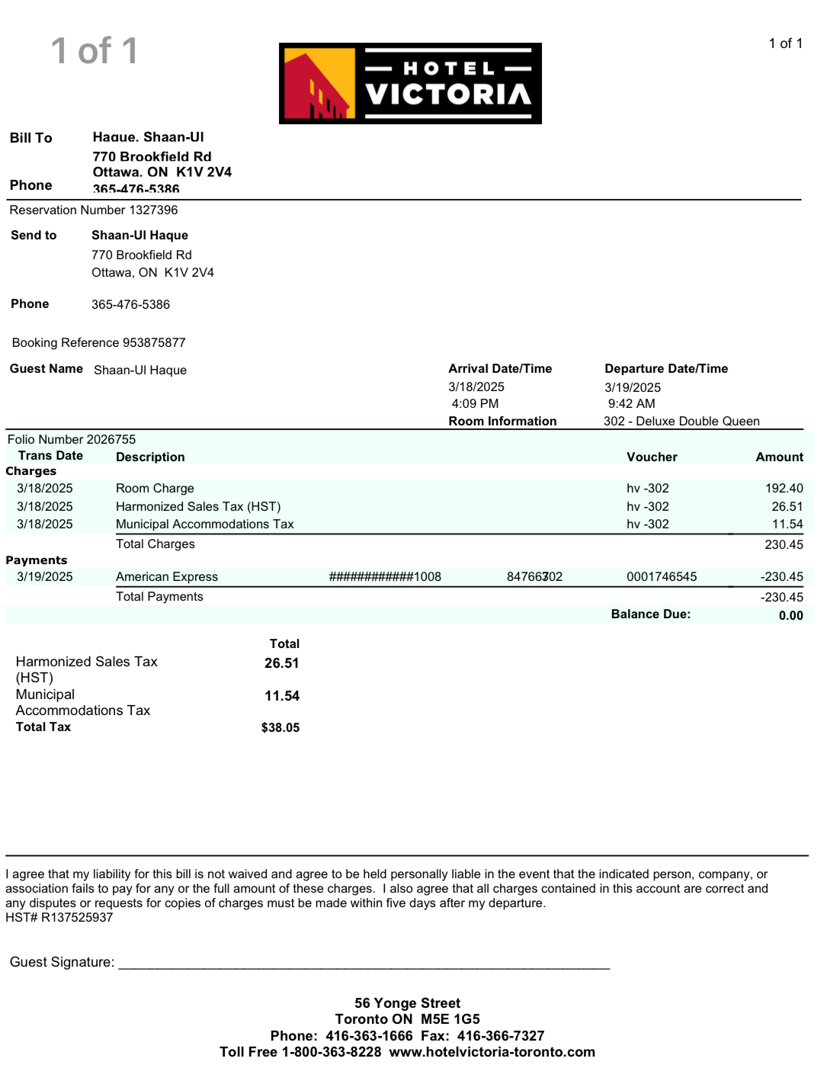

**Reason for Transaction:** Shaan’s hotel room purchase towards BIPOC Toronto Trip from March 18th-19th

## E-Transfer Line on Bank Account:



Original Receipts:

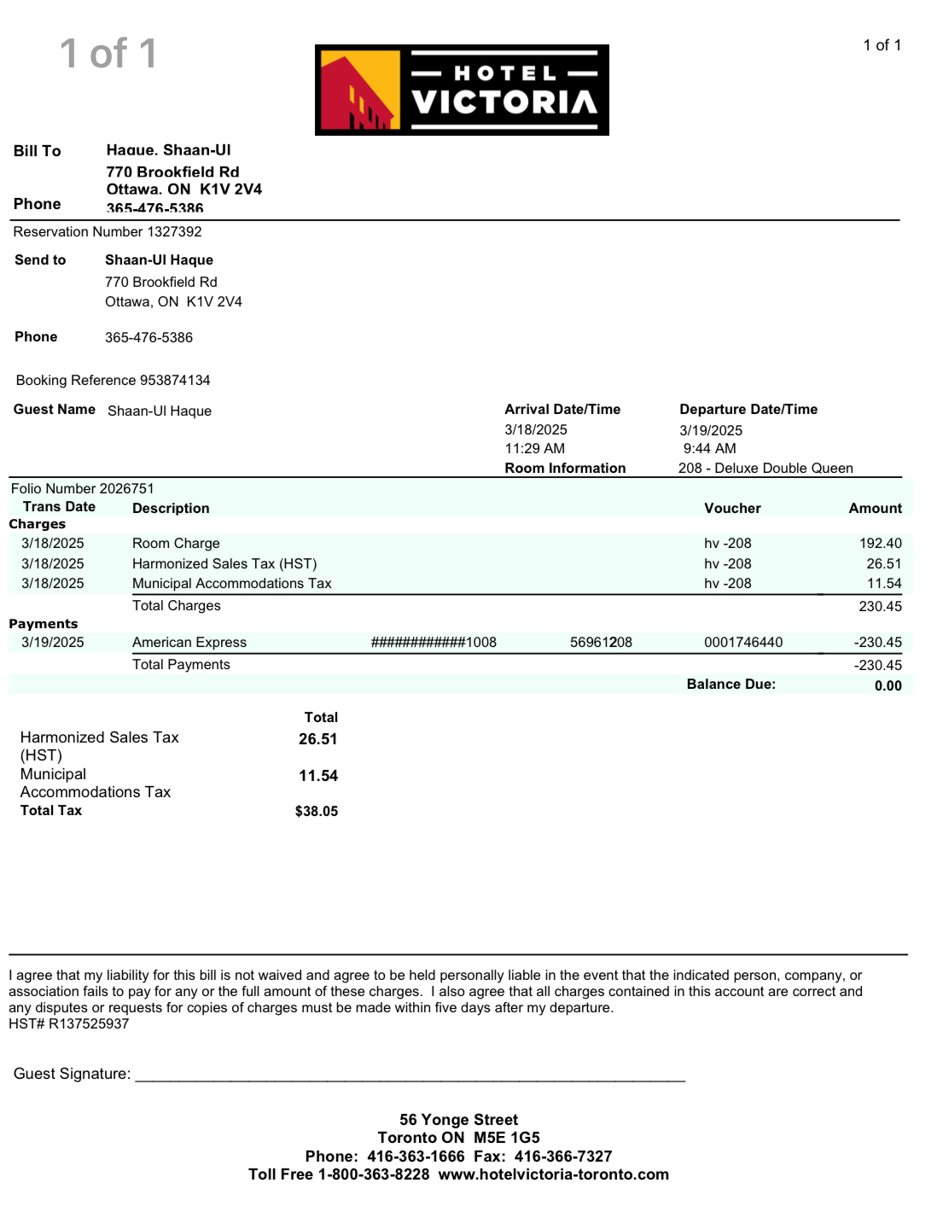

**Reason for Transaction:** Shaan’s hotel room purchase towards BIPOC Toronto Trip from March 18th-19th

## E-Transfer Line on Bank Account:



Original Receipts:

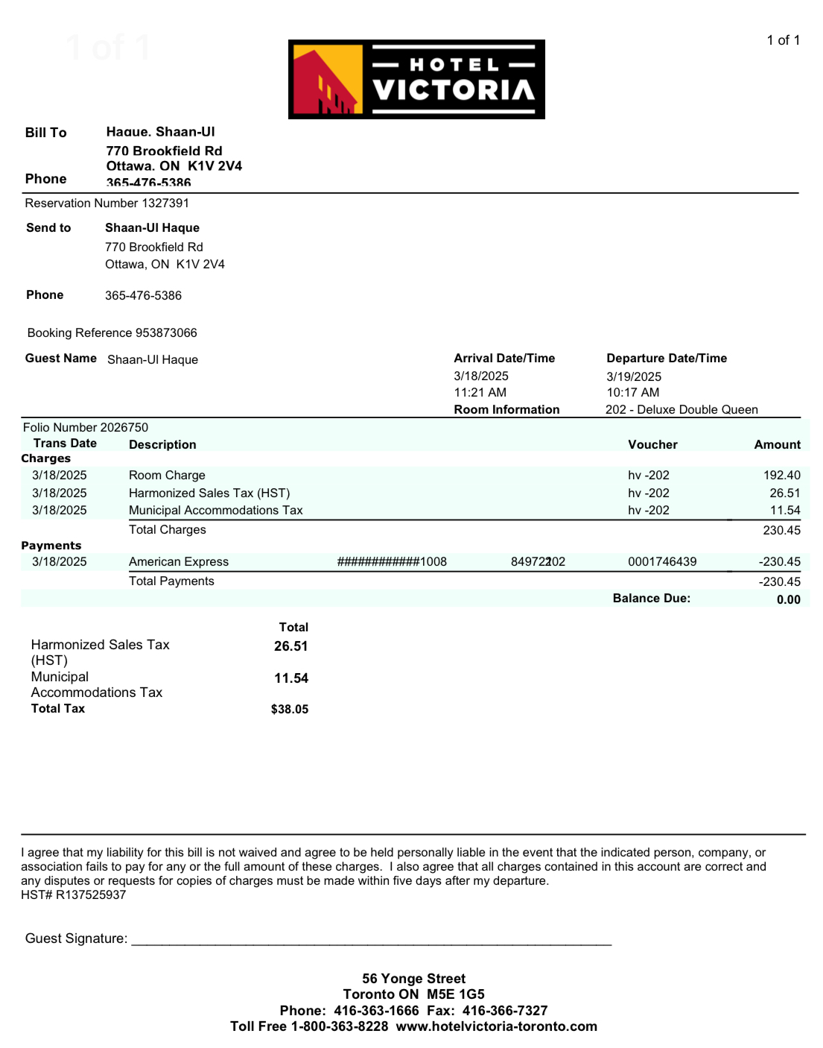

**Reason for Transaction:** Shaan’s hotel room purchase towards BIPOC Toronto Trip from March 18th-19th

## E-Transfer Line on Bank Account:



Original Receipts:

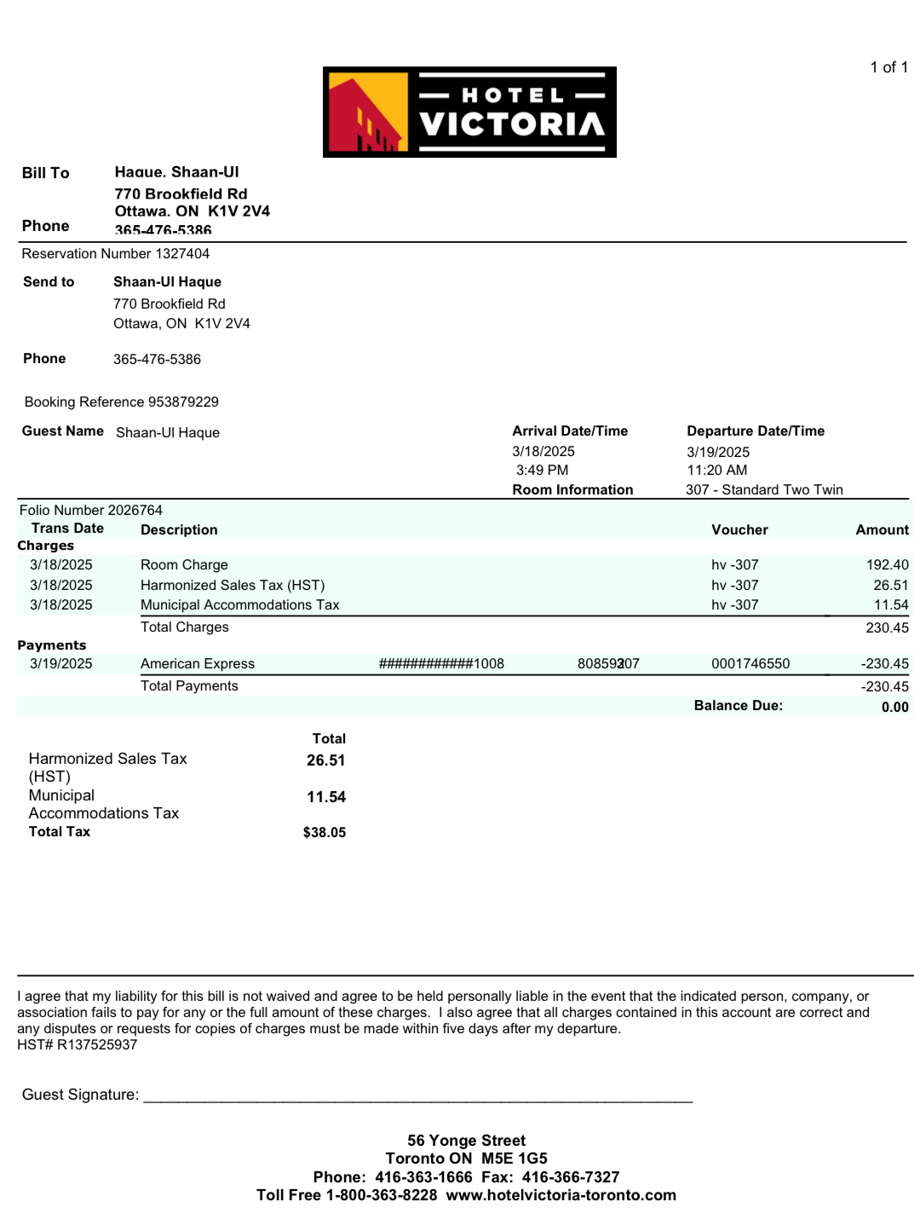

**Reason for Transaction:** Shaan’s hotel room purchase towards BIPOC Toronto Trip from March 18th-19th

## E-Transfer Line on Bank Account:



Original Receipts:

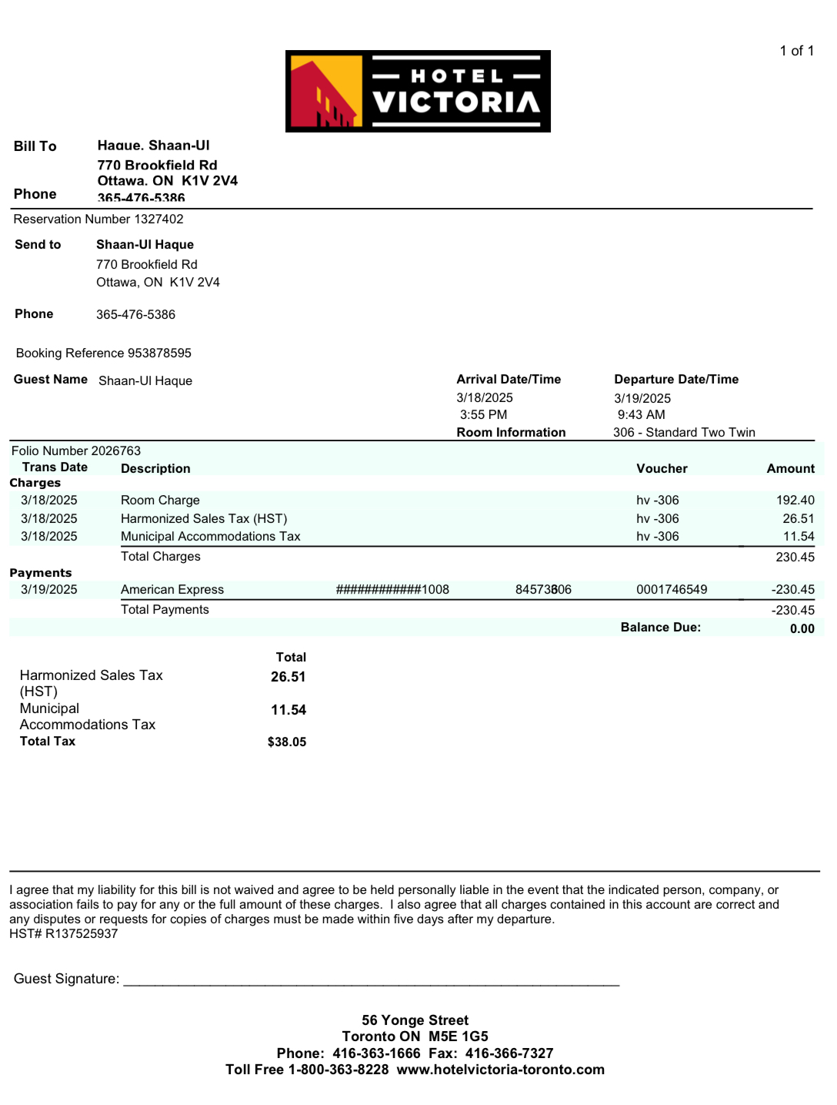

**Reason for Transaction:** Shaan’s hotel room purchase towards BIPOC Toronto Trip from March 18th-19th

## E-Transfer Line on Bank Account:



Original Receipts:

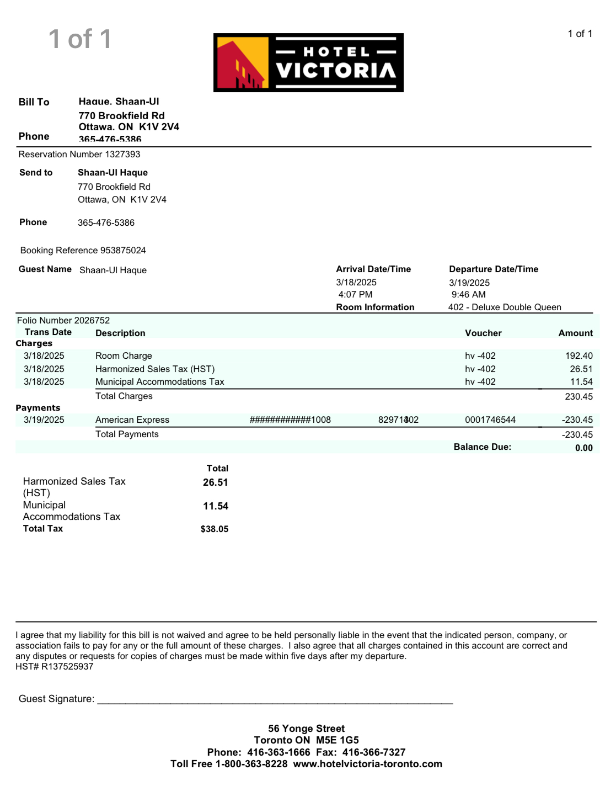

**Reason for Transaction:** Shaan’s hotel room purchase towards BIPOC Toronto Trip from March 18th-19th

## E-Transfer Line on Bank Account:

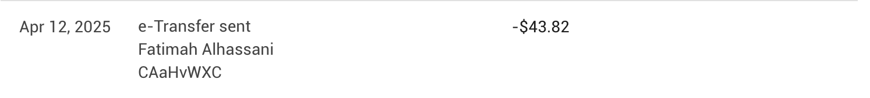

Original Receipts:

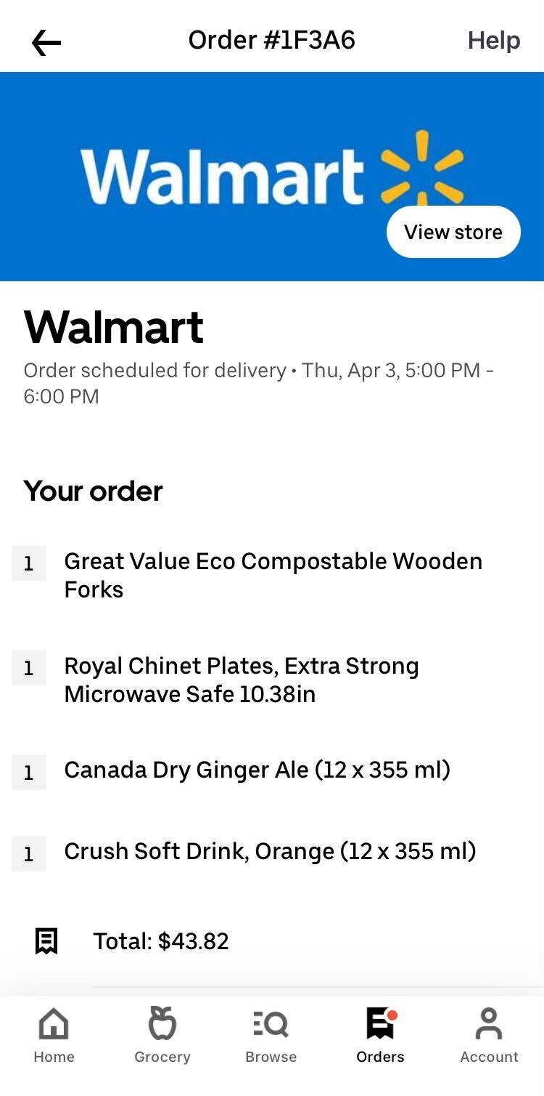

**Reason for Transaction:** Fatimah’s purchase towards April 3rd’s GM and movie night

## E-Transfer Line on Bank Account:

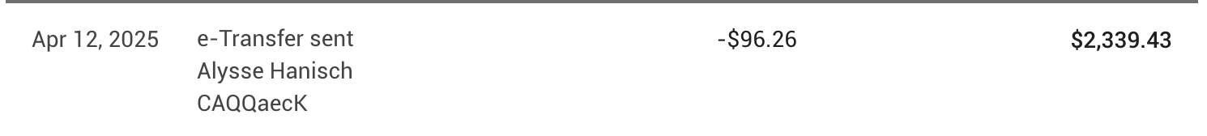

Original Receipts:

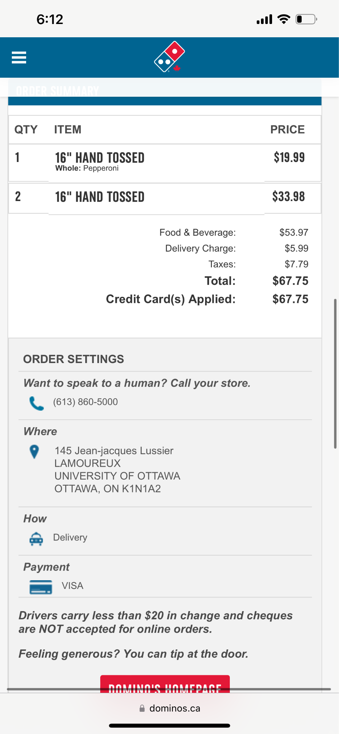

**Reason for Transaction:** Alysse’s purchase towards April 3rd’s GM and movie night

## E-Transfer Line on Bank Account:



Original Receipts:

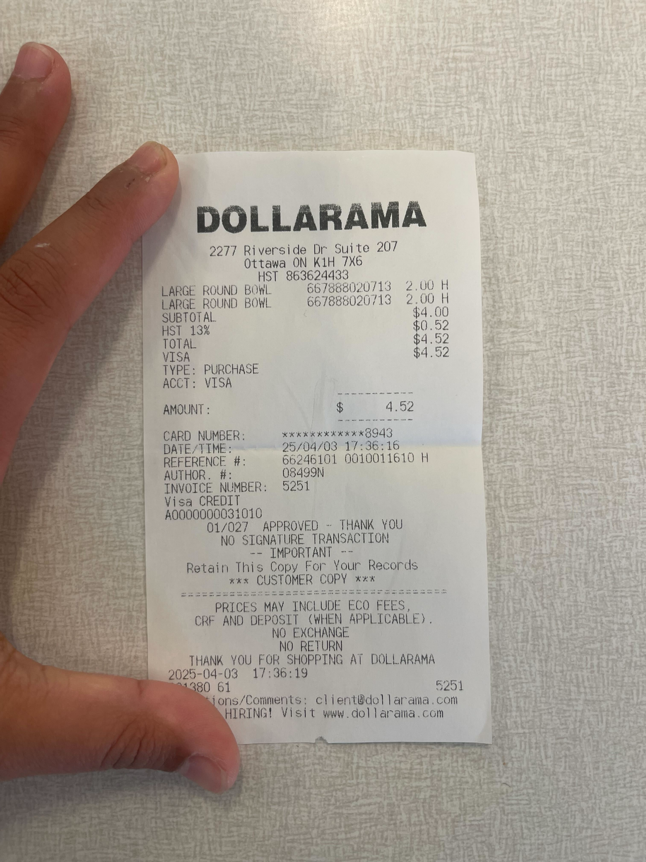

**Reason for Transaction:** Alysse’s purchase towards April 3rd’s GM and movie night

## E-Transfer Line on Bank Account:



Original Receipts:

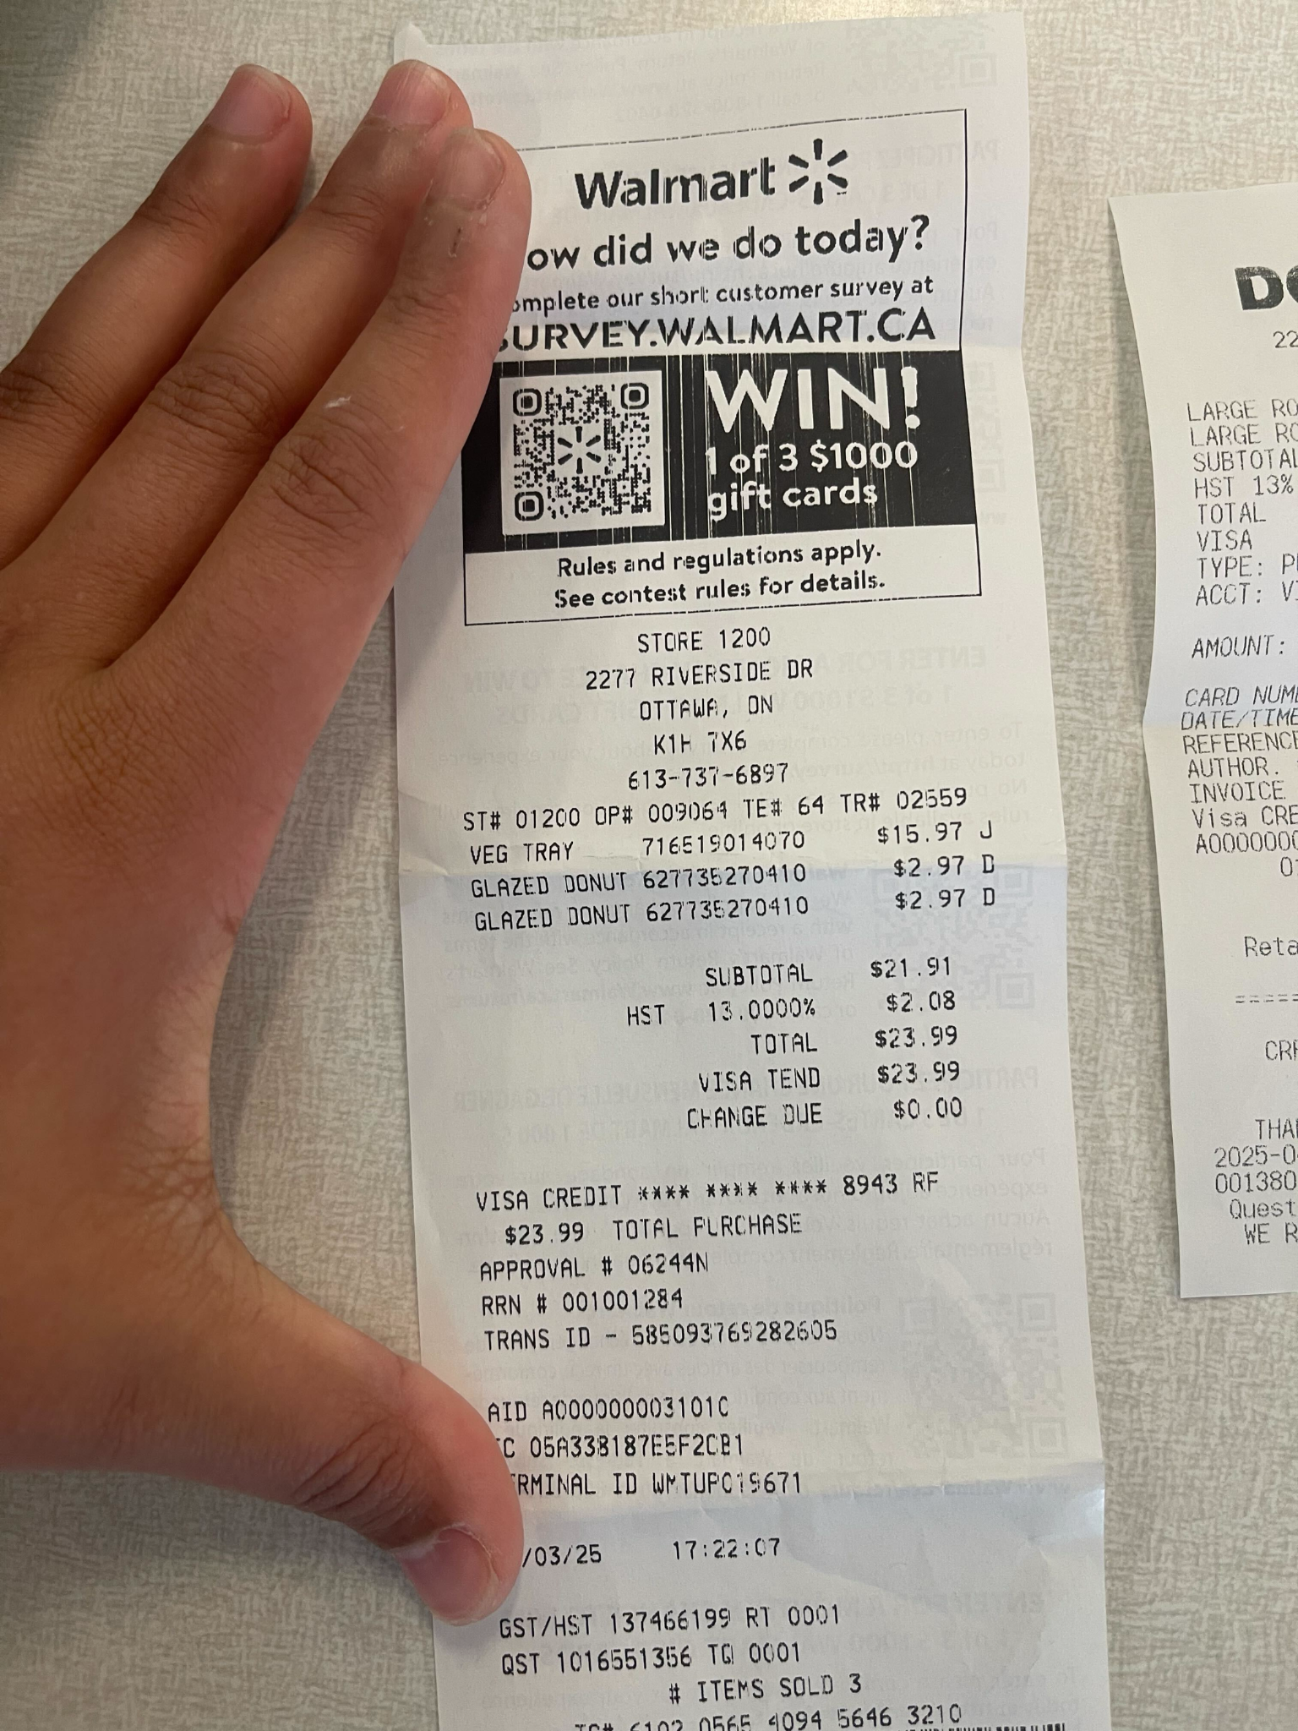

**Reason for Transaction:** Alysse’s purchase towards April 3rd’s GM and movie night

## E-Transfer Line on Bank Account:

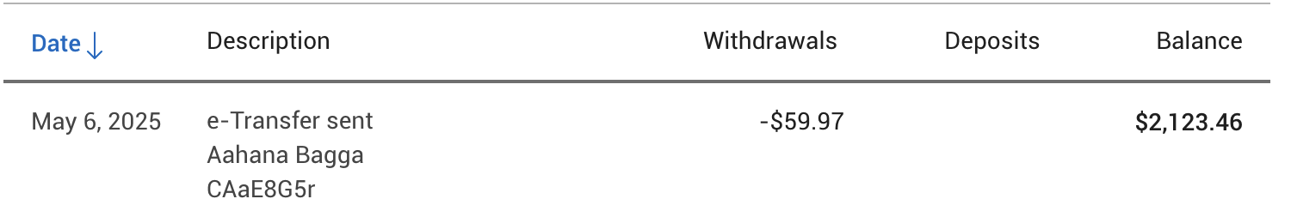

Original Receipts:

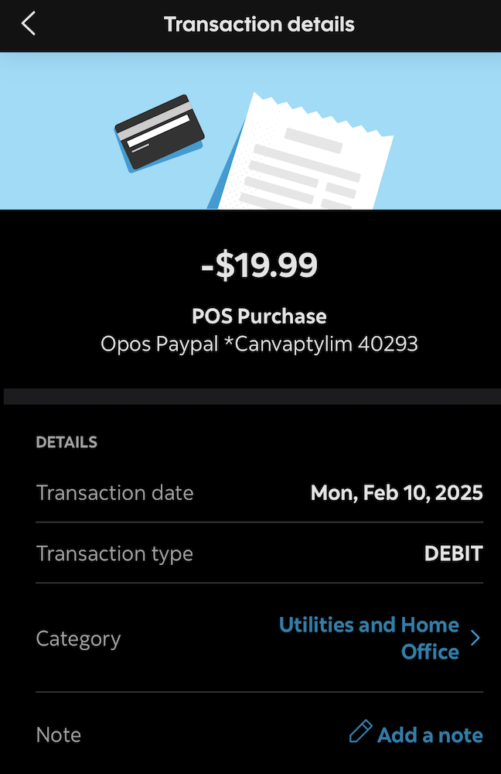

**Reason for Transaction:** Canva Bill made on February 10th

## E-Transfer Line on Bank Account:



Original Receipts:

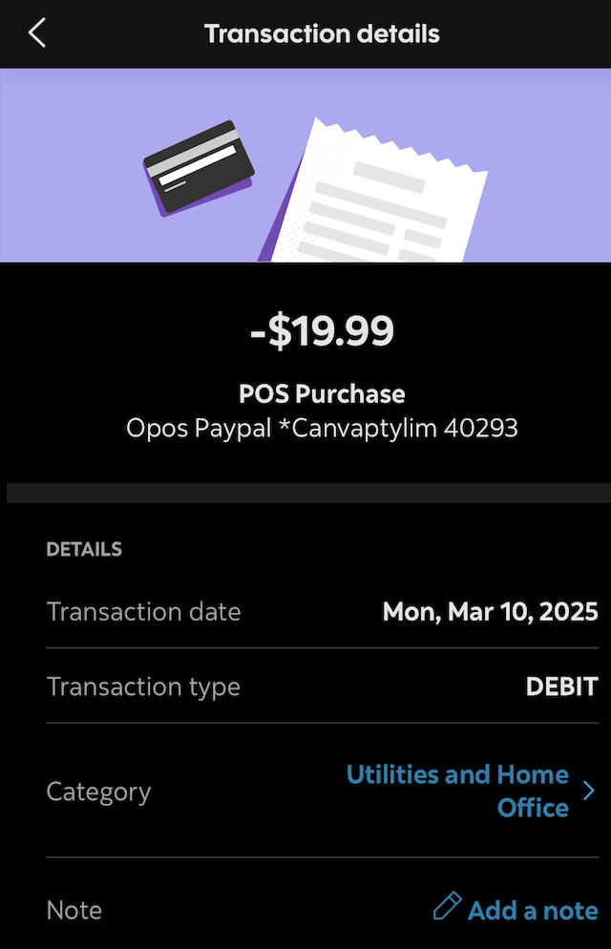

**Reason for Transaction:** Canva Bill made on March 10th

## 

## 

## 

## 

## 

## E-Transfer Line on Bank Account:



Original Receipts:

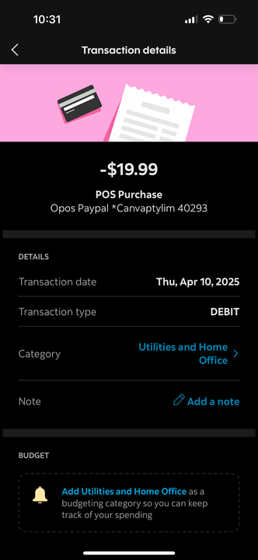

**Reason for Transaction:** Canva Bill made on April 10th